Eclipse Essentials 2013

### *Notes from a Lynda training series*

# Environment Preparation

* JavaSE 6r29 JDK(and JRE): java.oracle.com
* Set Path & Test: “C:\Program Files\Java\jre6\bin”
  + java -version
  + javac -version
* IDE
  + Eclipse: [www.eclipse.org/downloads](http://www.eclipse.org/downloads)
    - Eclipse IDE for Java Developers/Jave EE Developers

## JARs(include in Eclipse project when needed):

* TestND: <http://beust.com/eclipse>
* Java Excel API: <http://jexcelapi.sourceforge.net/>
  + <http://jexcelapi.sourceforge.net/resources/javadocs/2_3_8/docs/jxl/read/biff/BiffException.html>
* JUnit: <http://www.junit.org/>
* Apache ANT (HTML reporting)
* Subversion <http://subclipse.tigris.org/update_1.8.x>
* Also check: <http://download.eclipse.org/releases/juno/>

## Help and Tutorials

### Java/Selenium Reading from Excel sheets:

* <http://testerinyou.blogspot.com/2010/10/how-to-do-data-driven-testing-using.html>
* <http://functionaltestautomation.blogspot.com/2009/10/dataprovider-data-driven-testing-with.html>
* <http://www.youtube.com/watch?v=ty3q2wQdPmU&feature=BFp&list=WL18EEBB0491EF4A05>



## Shortcuts:

CTRL-SPACE Code writing

CTRL + / Add/remove comments

CTRL + SHFT + O Organize imports (Add/remove imports)

ALT + UP/DOWN Move a line of code up or down

CTRL + D Delete Line

ALT+SHFT+J Element Comment



# Starting Eclipse

## Eclipse Start.bat: JDK7

This uses the JDK7 binaries:

## Eclipse.ini Configuration: JDK7

set DEV\_HOME=D:\DEVL\Java

set JAVA\_HOME=%DEV\_HOME%\java32\jdk7

set PATH=%JAVA\_HOME%\bin;%PATH%

start %DEV\_HOME%\eclipse32\eclipse.exe -vm %JAVA\_HOME%\bin\javaw.exe -showlocation -vmargs -server -Xms512m -Xmx1024m -XX:MaxPermSize=128m

-startup

plugins/org.eclipse.equinox.launcher\_1.3.0.v20120522-1813.jar

--launcher.library

plugins/org.eclipse.equinox.launcher.win32.win32.x86\_1.1.200.v20120522-1813

-product

org.eclipse.epp.package.java.product

--launcher.defaultAction

openFile

--launcher.XXMaxPermSize

256M

-showsplash

org.eclipse.platform

--launcher.XXMaxPermSize

256m

--launcher.defaultAction

openFile

-vm

D:/DEVL/Java/java32/java32/jdk7/bin/javaw.exe

-vmargs

-Dosgi.requiredJavaVersion=1.5

-Dhelp.lucene.tokenizer=standard

-Xms40m

-Xmx512m



# HOME Environment Variable

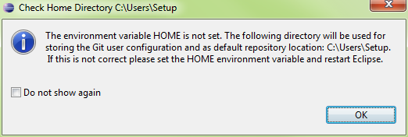



# Installing the Subversion Client

* Go to Help\Eclipse Marketplace and search by ‘Subversion’
* Select Subclipse and Install…
* <http://subclipse.tigris.org/update_1.8.x>
* Go to Preferences\Team\SVN
* The SVN interface should be JavaHL(JNI)
* Here it is Not Available

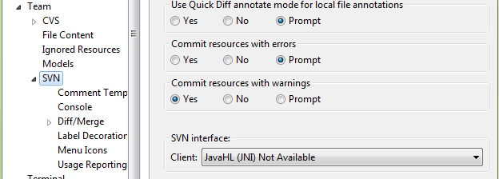

* If the Subclipse client plugins are missing, the following prompt will appear

#### Subclipse Library Not Available

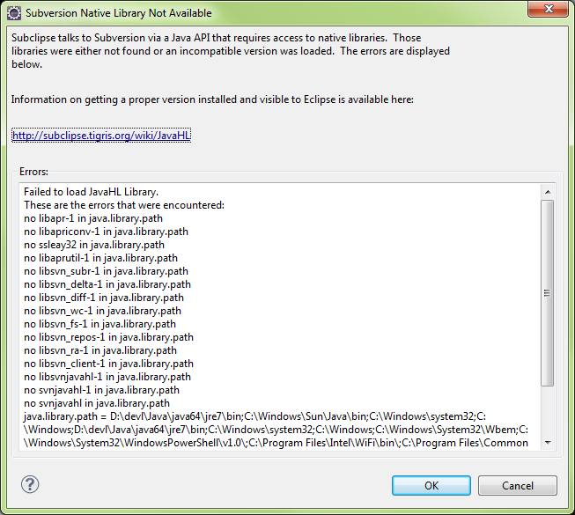

## Installing Subclipse from Help\New Software

* Go to Help\Install New Software…

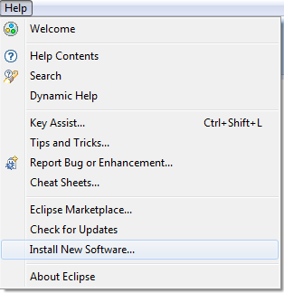

#### Locate “Subclipse – http://...”

Select Subclipse option, Click Next

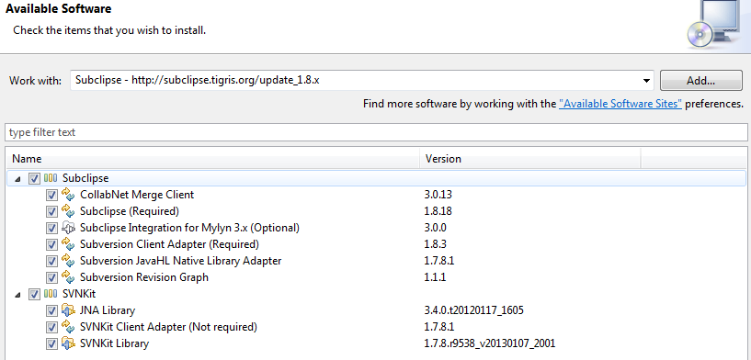

#### Acknowledge EULAs

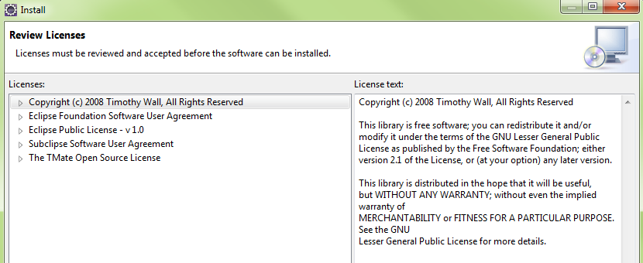

#### Eclipse will download selected packages

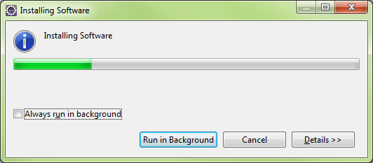

#### Security Warning

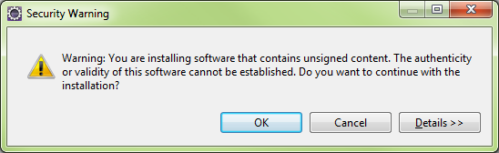

#### Eclipse will restart

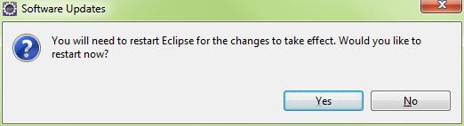



## Installing Subclipse From Help\Eclipse Market Place…

#### Eclipse Marketplace: Subclipse selection

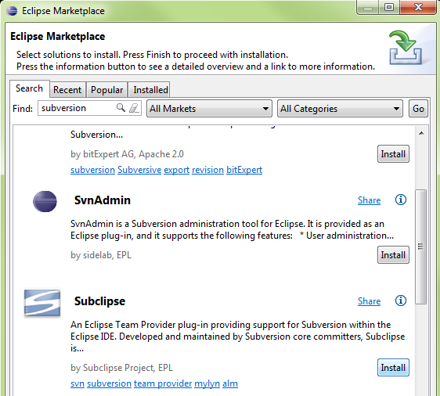

#### Select all packages

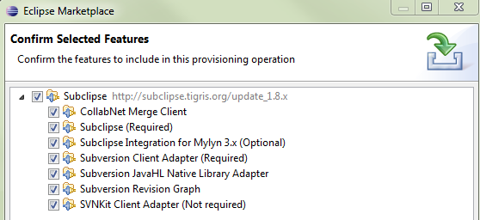

#### Acknowledge the EULAs

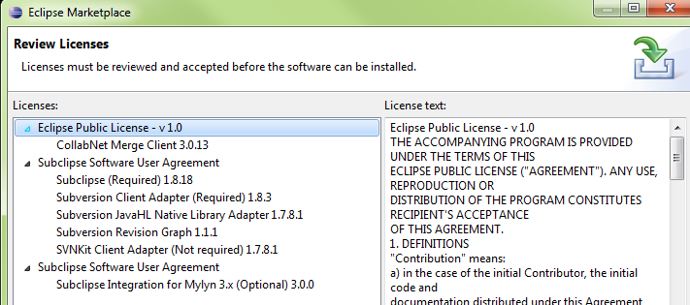

#### Eclipse will download the packages

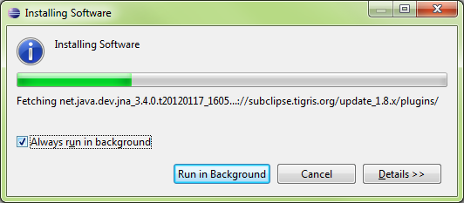

Upon restarting, Eclipse will prompt for communicating Subclipse usage

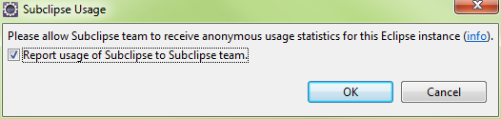



## Enabling the SVN Connector and Plugin

#### Eclipse\Preferences\Team\SVN

Select SVN interface: JavaHL and press OK

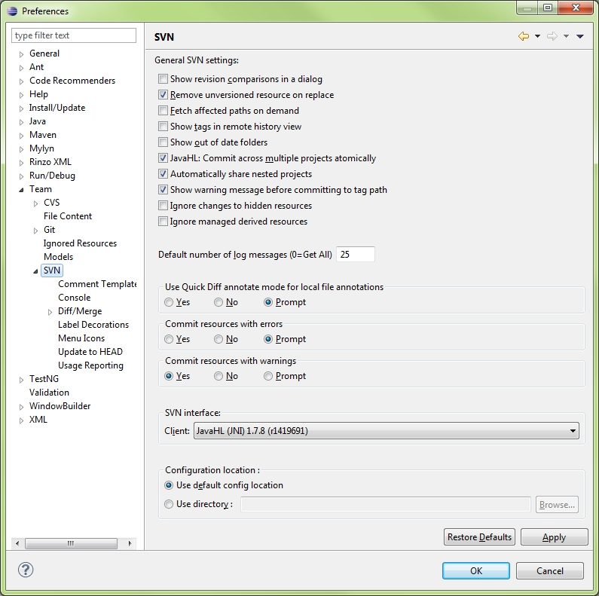

#### Open the SVN Repository View

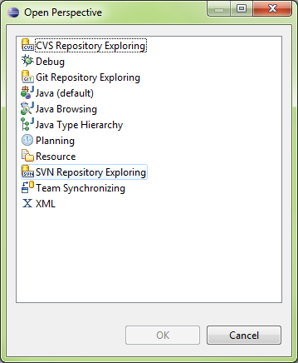

#### The SVN repository Exporting Panel will appear



#### Right Click in the SVN repositories panel, select New..

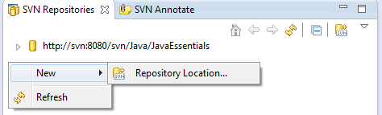

#### Enter the URL of the SVN Server and Repository

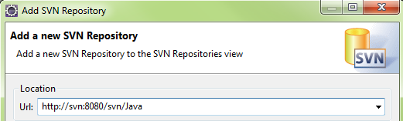

#### If Incorrect, Eclipse will indicate an Error

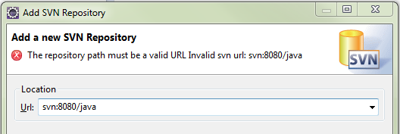

#### Accessing SVN from the Project Explorer

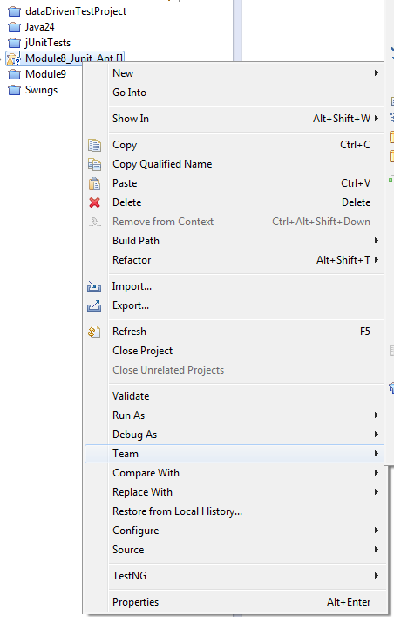



# Eclipse About

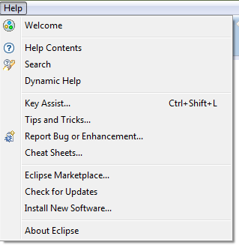

#### About Main Form

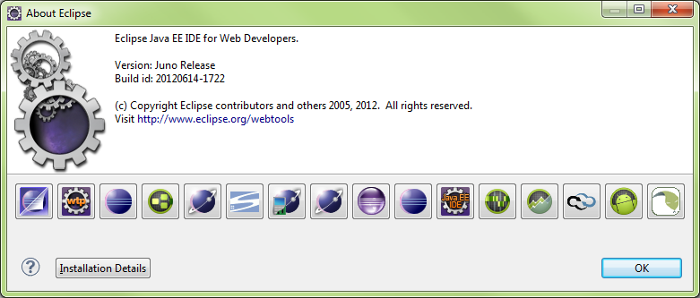

#### Installation Details

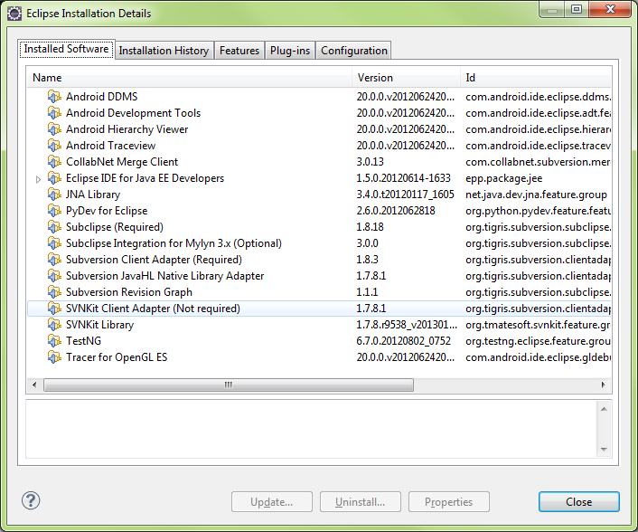

#### Installation History

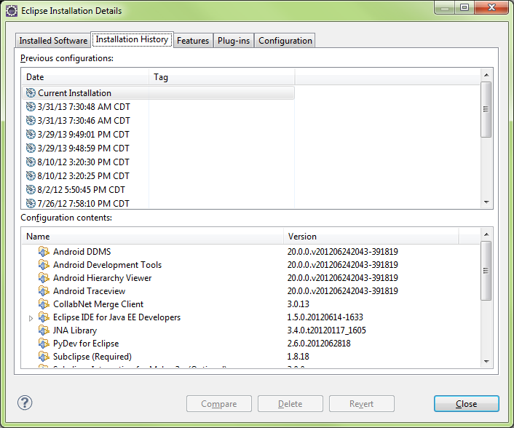

#### Features

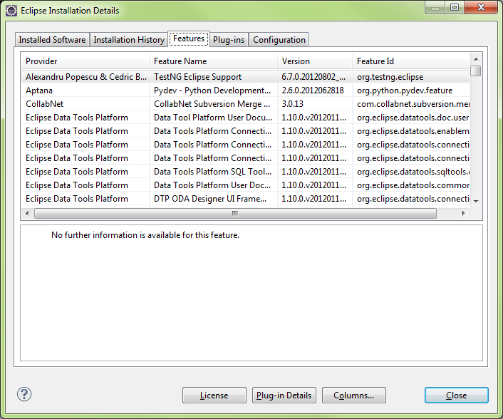

#### Plugins

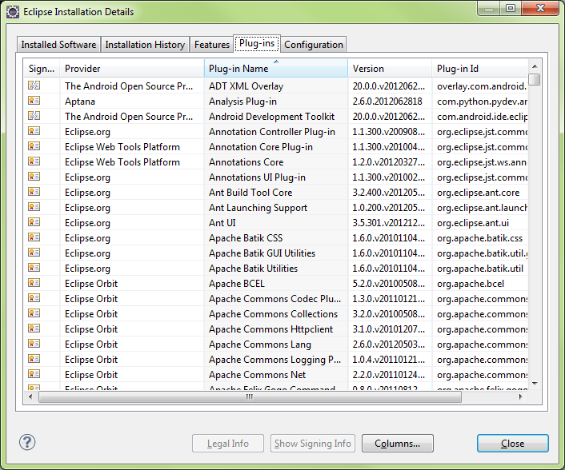

#### Eclipse Installation Details

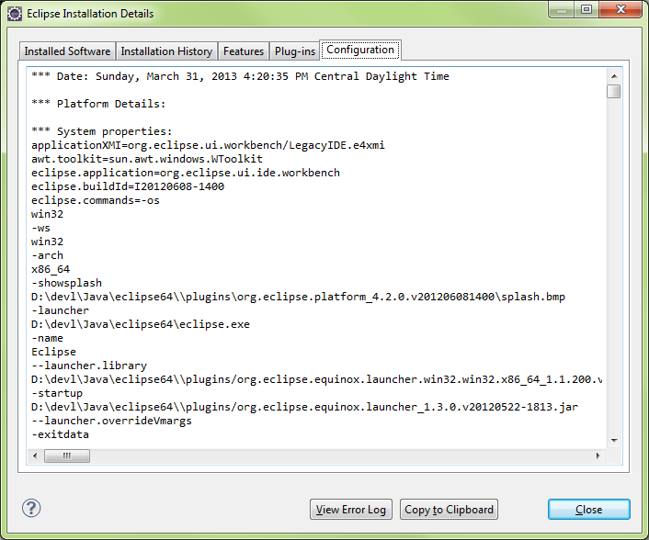



# Eclipse Help



#### Main Contents View

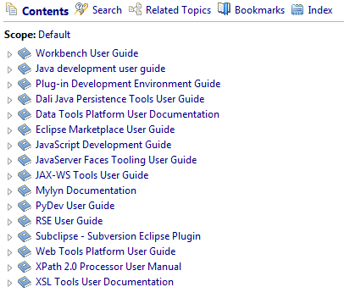

#### Help Contents Expanded

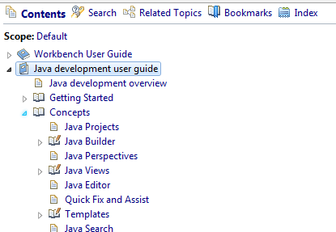

#### Help Index

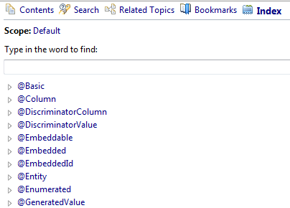

#### Help Search

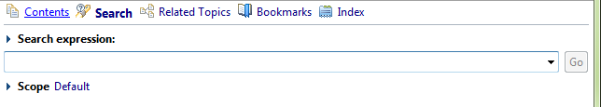



# Mylyn Task Manager

|  |
| --- |
| Mylyn is a Task-Focused Interface for Eclipse that reduces information overload and makes multi-tasking easy. It does this by making tasks a first class part of Eclipse, and integrating rich and offline editing for repositories such as Bugzilla, Trac, and JIRA. Once your tasks are integrated, Mylyn monitors your work activity to identify information relevant to the task-at-hand, and uses this task context to focus the Eclipse UI on the interesting information, hide the uninteresting, and automatically find what's related. This puts the information you need to get work done at your fingertips and improves productivity by reducing searching, scrolling, and navigation. By making task context explicit Mylyn also facilitates multitasking, planning, reusing past efforts, and sharing expertise. |

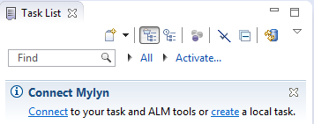

# MAVEN

## Eclipse M2E Installation

#### Searching repositories

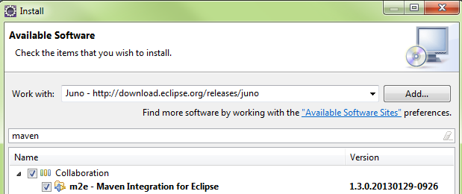

#### Install Details

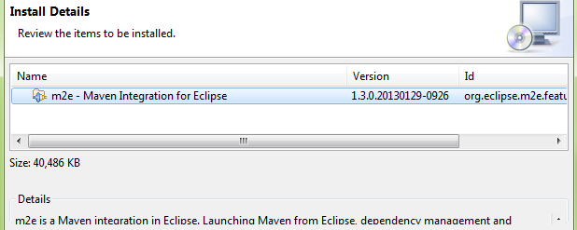

#### Review Licenses

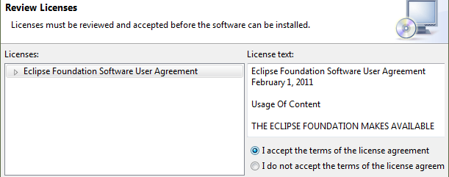

#### Installing Software

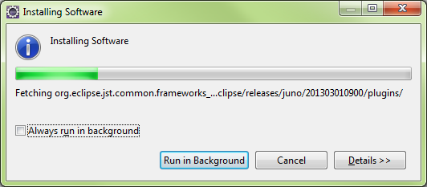

#### Restart

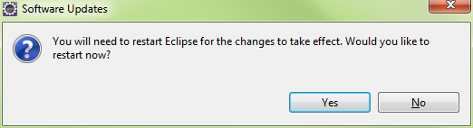

## Eclipse Maven Configuration

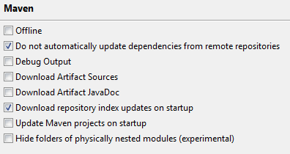

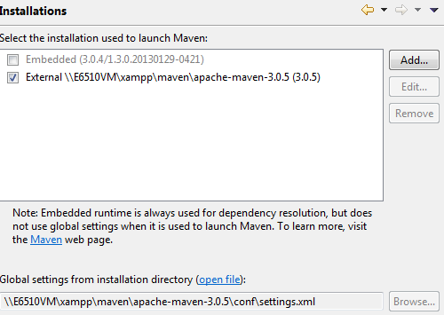 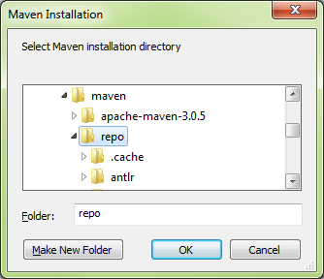

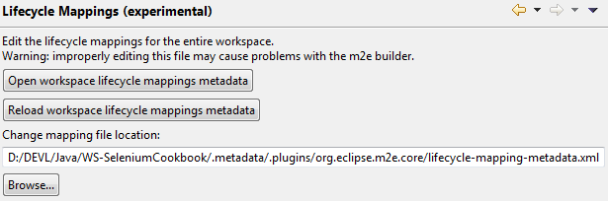

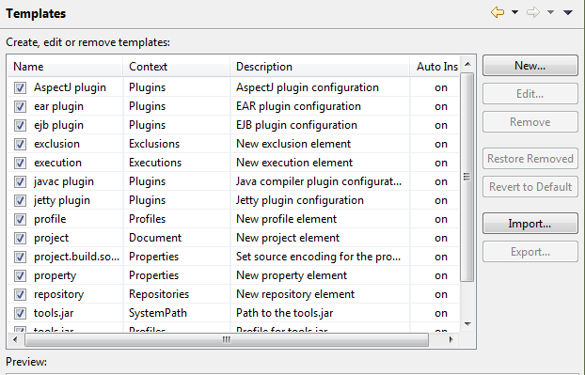

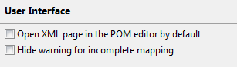

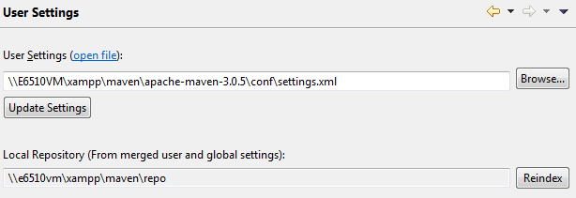

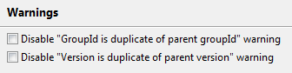

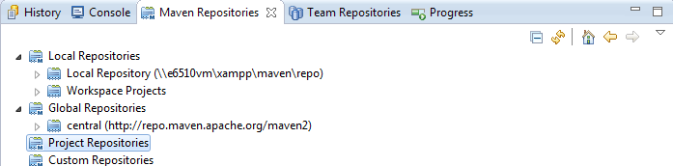



# Eclipse Development

## Create Workspace

* Create WORKSPACE folder to contain PROJECTS
* New, Project....
* New, Class....(.java file is the class)

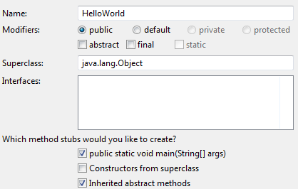

* Window > Prefrences > General > Appearance > Colors and Fonts.. > Text Font
* Run > Run Configurations... >

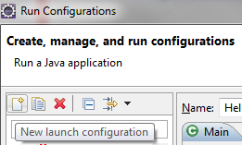

## New Project

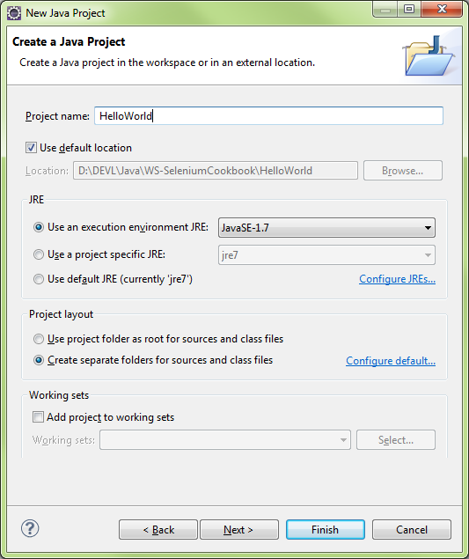

### JRE Section

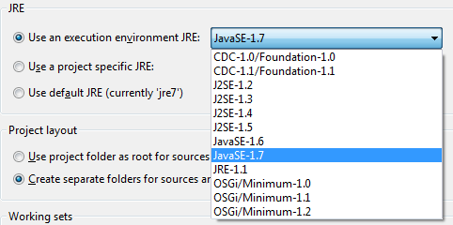

### Configure JREs

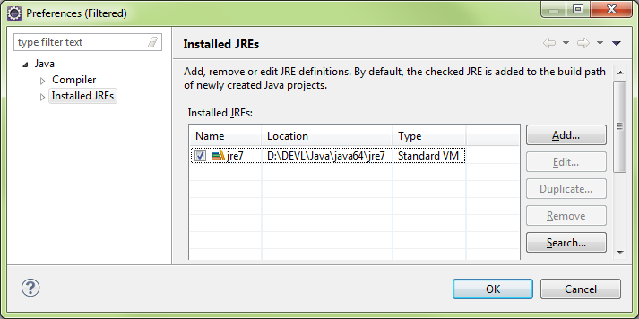

### Configure Defaults

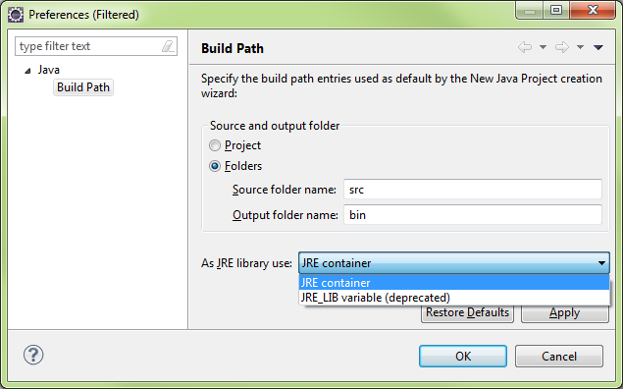

## Import Projects

* File > Import > General > Existing Project into Workspace
  + Exploded Project (Root Dir)
  + Zipped Project (Archive File)
  + Root Dir, OK
  + Eclipse will autodetect projects
  + Copy projects into workspace
* Close projects that aren’t in use (Right-Click, Close Project)
  + Projects remain in workspace, just not open

## Missing Dependencies and References

When opening a project, several errors can occur, such as missing depencies or references.

In this case, there is a missing JAR file

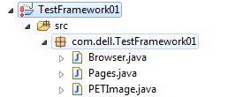

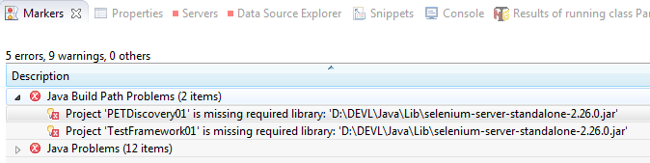

Right-click the error and select properties for more detailed look

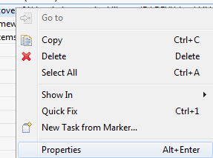

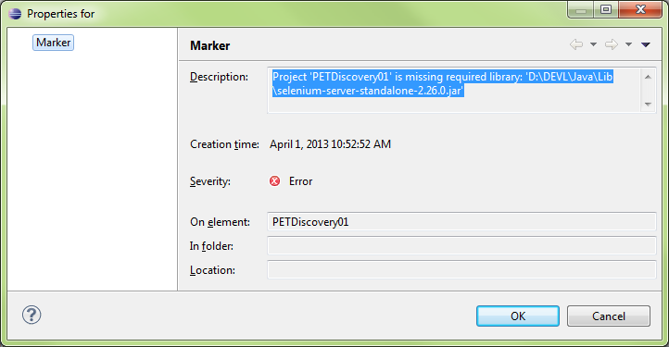

Right-click the project and select properties or press ALT-ENTER to bring u the project properties

Select the missing package and press Edit to select a new path to the file

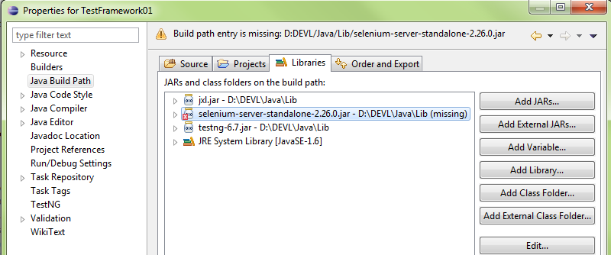

## IDE Layout

HutuBBB

**Views/Panels**

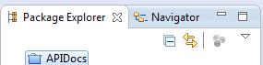



## Perspectives

* Arrangement of Views
* 
* Custom Perspectives: **Window > Save Perspective As....**

## Command Line

* Dir to PROJECT\SRC
* javac Main.java
  + dir = Main.class
  + java Main
* javac Main.java -d ..\bin
  + \src\Main.class
* javac Main.java -verbose

### Note: Access Denied Errors

If **Access Denied** error occurs, set folder permissions to Everyone and give **Full Control** access.

D:\Eclipse\Java\CommandLine\src>javac Main.java -d D:\Eclipse\Java\CommandLine\bin

Main.java:2: error while writing Main: D:\Eclipse\Java\CommandLine\bin\Main.class (Access is denied

public class Main {

^

## ClassPath

Similar to the classic [dynamic loading](http://en.wikipedia.org/wiki/Library_(computing)" \l "Dynamic_loading) behavior, when executing [Java](http://en.wikipedia.org/wiki/Java_(programming_language)) programs, the [Java Virtual Machine](http://en.wikipedia.org/wiki/Java_Virtual_Machine) finds and loads classes lazily (it loads the [bytecode](http://en.wikipedia.org/wiki/Java_bytecode) of a class only when this class is first used). The classpath tells Java where to look in the filesystem for files defining these classes.

The virtual machine searches for and loads classes in this order:

1. bootstrap classes: the classes that are fundamental to the [Java Platform](http://en.wikipedia.org/wiki/Java_Platform) (comprising the public classes of the [Java Class Library](http://en.wikipedia.org/wiki/Java_Class_Library), and the private classes that are necessary for this library to be functional).
2. extension classes: [packages](http://en.wikipedia.org/wiki/Java_package) that are in the *extension* directory of the [JRE](http://en.wikipedia.org/wiki/JRE) or [JDK](http://en.wikipedia.org/wiki/JDK), jre/lib/ext/
3. user-defined packages and libraries

By default only the packages of the [JDK](http://en.wikipedia.org/wiki/JDK) [standard API](http://en.wikipedia.org/wiki/Java_Platform,_Standard_Edition) and extension packages are accessible without needing to set where to find them. The path for all user-defined [packages](http://en.wikipedia.org/wiki/Java_package) and libraries must be set in the command-line (or in the [Manifest](http://en.wikipedia.org/wiki/Manifest_file) associated with the [Jar file](http://en.wikipedia.org/wiki/JAR_(file_format)) containing the classes).

## Setting the path through an environment variable

The [environment variable](http://en.wikipedia.org/wiki/Environment_variable) named CLASSPATH may be alternatively used to set the classpath. For the above example, we could also use on Windows:

Sometimes you have to check the JAVA\_HOME also, if it is pointing towards the right JDK version

set CLASSPATH=D:\myprogram  
java org.mypackage.HelloWorld

## Diagnose

Application programmers may want to find out/debug the current settings under which the application is running:

System.getProperty("java.class.path")



## Compiling and Running

Java package statement implies the directory structure where it exists within the project.

Should be unique

* package **com**.**lynda**.**javatraining**;
* \src\**com**\**lynda**\**javatraining**\**HelloWorld**.java

When compiling, use javac in the project root:

* C:\JavaProjects\HelloWorld>javac com\lynda\javatraining\HelloWorld.java
  + HelloWorld.class
  + HelloWorld.java

When running, use package reference and filename **without** “.java” extension

* C:\JavaProjects\HellowWorld>java **com**.**lynda**.**javatraining.HelloWorld**

public class **HelloWorld** {

public static void main(String[] args) {

* **Static: allows class to be called directly?**

|  |
| --- |
| public class **HelloWorld** {  public static void main(String[] args) {   * **Static: allows class to be called directly?** |



# Project Errors

Error: Build Path specifics execution environment JavaSE1.6. There are no FREs installed in the workspace that are strictly compatible with the environment…

Fix: Add an additional JRE Library to the project and reference that in lieu of JRE7

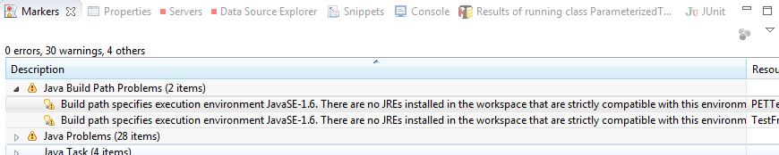

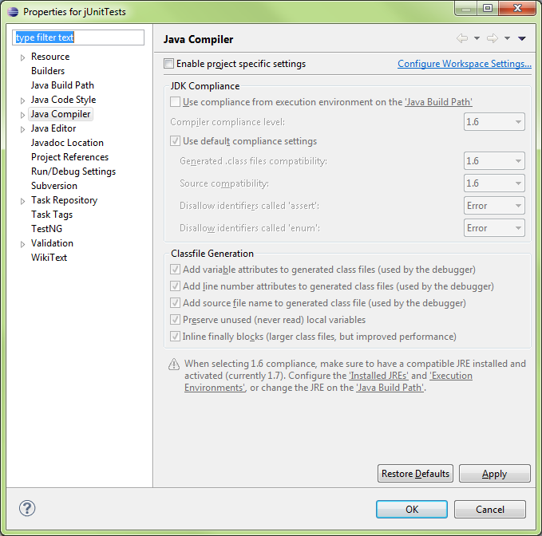

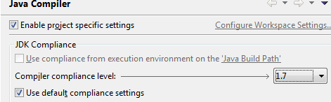

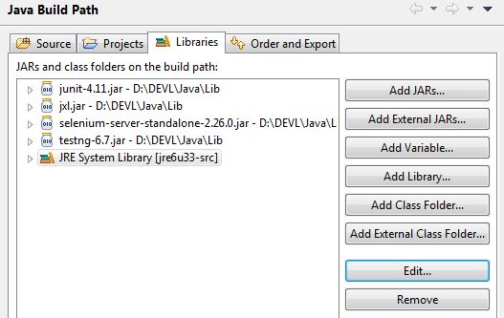

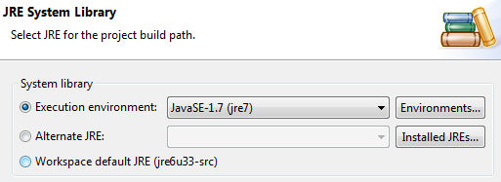

Press the Environments button to update the package refences

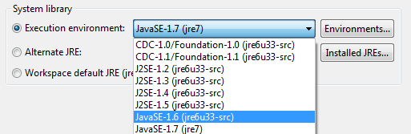

* IN this case, JavaSE-1.6 was mentioned in the error message so probably best to find a matching JRE for it
* jre6u33-src shows to be a [perfect match] for the requirement, so we’ll select it.

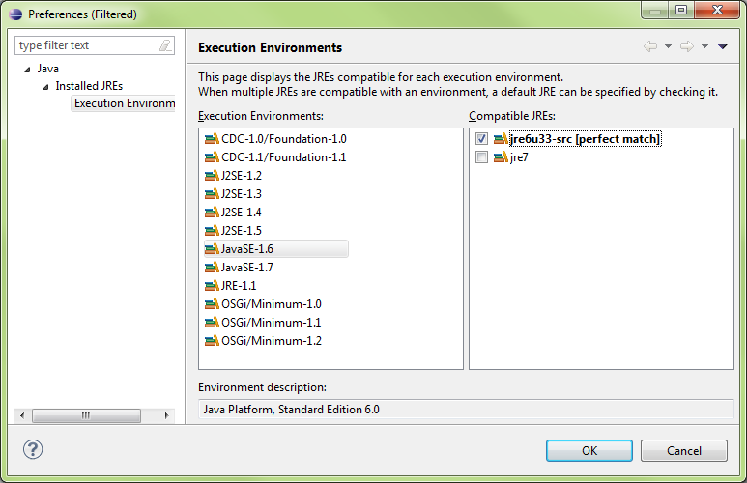



# Java Language Tools

## Main Class

**public static void main(String[] args) {**

### Required by Class:

* public - can be called anywhere
* static - no instance required to run
* void - nothing returned by class
* String[] args
  + [] - an array
  + args - default variable to hold passed data
  + Passed by Java’s JVM

## Passing Args

### Command Line

java Main arg1 arg2

### In Eclipse:

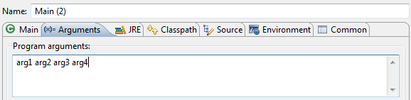



## Switch Statements: Enums

Project > New > Enum

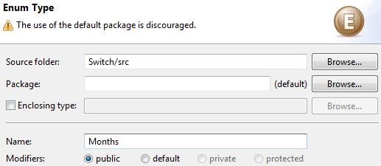

**Code:**

public enum Month {

JANUARY, FEBRUARY, MARCH; //Constants of enum class

}

public class SwitchWithEnums {

// Enumerations

public static void main(String[] args) {

// int month = 1;

Month month = Month.FEBRUARY;

switch(month) {

case JANUARY:

System.out.println("It's the first month");

break;

case FEBRUARY:

System.out.println("It's the second month");

break;

case MARCH:

System.out.println("Its the third month");

}

}

}



## Methods

### Refactoring

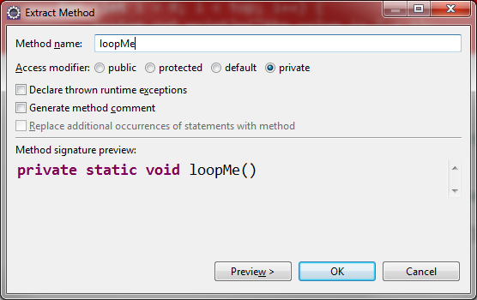

**Code:**

public class Main {

public static void main(String[] args) {

doSomething();

//refactoring, copy code, Refactor..

//will create a new method and reference it here

loopMe();

}

private static void loopMe() {

int top = 10;

for (int i = 0; i < top; i++) {

System.out.println("the value is " + i);

}

}

//Access modifier public, private, protected (inheritance), none (protected package)

//Static - class method, only used inside class

//non-Static - used in instances

//Static must create instance to call non-Static '.method()'

private static void doSomething() {

System.out.println("This method has been called");

}

}



## Extracting a Method

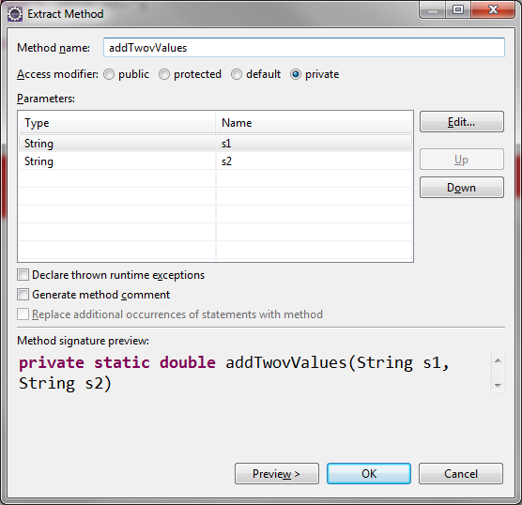

**Code:**

import java.io.\*;

public class Calculator {

public static void main(String[] args) {

String s1 = getInput("Enter a numeric value: ");

String s2 = getInput("Enter a numeric value: ");

// Extracting a Method

double result = addTwovValues(s1, s2);

System.out.println("The answer is " + result);

}

// Extracted Method

private static double addTwovValues(String s1, String s2) {

double d1 = Double.parseDouble(s1);

double d2 = Double.parseDouble(s2);

double result = d1 + d2;

return result;

}

private static String getInput(String prompt) {

BufferedReader stdin = new BufferedReader(

new InputStreamReader(System.in));

System.out.print(prompt);

System.out.flush();

try {

return stdin.readLine();

} catch (Exception e) {

return "Error: " + e.getMessage();

}

}

}



## Extract Method with Error Handling

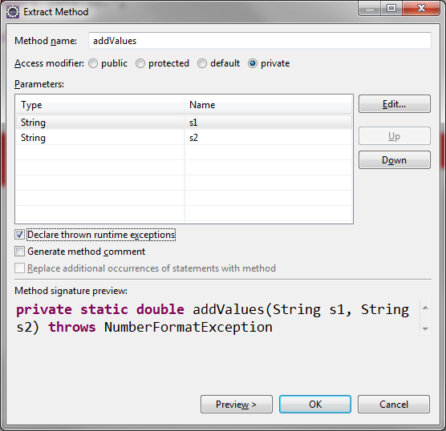



## Extracting and Error Handling with Try/Catch Block: Revisited

String[] strings = {"Welcome!"};

System.out.println(strings[1]);

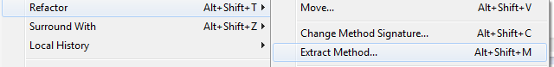

..

getArrayItem(); //refactored getArrayItem()

..

private static void getArrayItem()

throws ArrayIndexOutOfBoundsException {

String[] strings = {"Welcome!"};

System.out.println(strings[1]);

}



try {

getArrayItem(); //refactored getArrayItem()

} catch (ArrayIndexOutOfBoundsException e) {

// e.printStackTrace(); // <--- throws ugly message

System.out.println("Array item was out of bounds");

}

**Code:**

public class Main {

public static void main(String[] args) {

//Extrac Method with Error Handling

//Surround with try/catch blcok

try {

getArrayItem(); //refactored getArrayItem()

} catch (ArrayIndexOutOfBoundsException e) {

// e.printStackTrace(); // <--- throws ugly message

System.out.println("Array item was out of bounds");

//Array item was out of bounds

}

}

private static void getArrayItem()

throws ArrayIndexOutOfBoundsException {

String[] strings = {"Welcome!"};

System.out.println(strings[1]);

}

}



## Debugger

Finding Possible Exceptions

Highlight command > Help > Dynamic Help > JavaDoc > CONSTRUCTOR > METHOD

URI uri = new URI("http:\\somecompany.com");

java.net.URISyntaxException: Illegal character in opaque part at index 5: http:\somecompany.com

at java.net.URI$Parser.fail(Unknown Source)

at java.net.URI$Parser.checkChars(Unknown Source)

at java.net.URI$Parser.parse(Unknown Source)

at java.net.URI.<init>(Unknown Source)

at Main.main(Main.java:10)

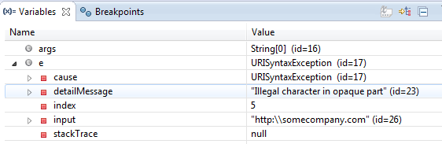

From e.printStackTrace();

To System.out.println(e.getMessage());

### Code:

import java.net.URI;

import java.net.URISyntaxException;

public class Main {

public static void main(String[] args) {

//Uniform Resource Identifier

try {

URI uri = new URI("http:\\somecompany.com");

} catch (URISyntaxException e) {

System.out.println(e.getMessage());

/\*

e.printStackTrace();

java.net.URISyntaxException: Illegal character in opaque part at index 5: http:\somecompany.com

at java.net.URI$Parser.fail(Unknown Source)

at java.net.URI$Parser.checkChars(Unknown Source)

at java.net.URI$Parser.parse(Unknown Source)

at java.net.URI.<init>(Unknown Source)

at Main.main(Main.java:10)

\*/

}

System.out.println("I'm alive!");

//Exception in thread "main" java.lang.Error: Unresolved compilation problem:

// Unhandled exception type URISyntaxException

// at Main.main(Main.java:8)

}

}



## Classes

* Class = Filename.java
* Only one public class per java file
* Multiple classes only accessible within the files
* Refactoring is process of pulling code out, creating method/class
  + Also changing class name is refactoring



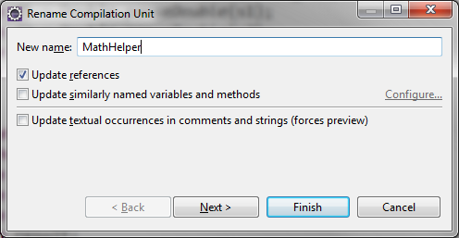

**Code:**

### From

result = **divideValues**(s1, s2);

### To

result = **SimpleMath**.**divideValues**(s1, s2);

### From

----------------------------------------------------------

public class **Calculator2** {

**private** static double **divideValues**(String s1, String s2) {

double d1 = Double.parseDouble(s1);

double d2 = Double.parseDouble(s2);

double result = d1 / d2;

return result;

----------------------------------------------------------

### To

----------------------------------------------------------

public class **SimpleMath** {

**public** static void main(String[] args) {

}

public static double **divideValues**(String s1, String s2) {

double d1 = Double.parseDouble(s1);

double d2 = Double.parseDouble(s2);

double result = d1 / d2;

return result;

----------------------------------------------------------



## Packages

* If class is anywhere but default package, it must be declared
* when creating packages, use reverse domain...
  + com.silosix.calc

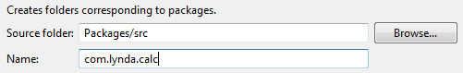

### Importing Packages

package com.lynda.calc;

import com.lynda.calc.helpers.InputHelper;

import com.lynda.calc.helpers.MathHelper;

**same as:**

package com.lynda.calc;

import com.lynda.calc.helpers.\*;

**CTRL-O will change \* to specific class imports**

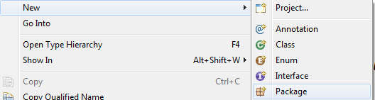

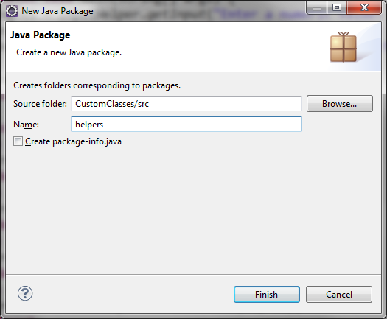

### Refactor > Move



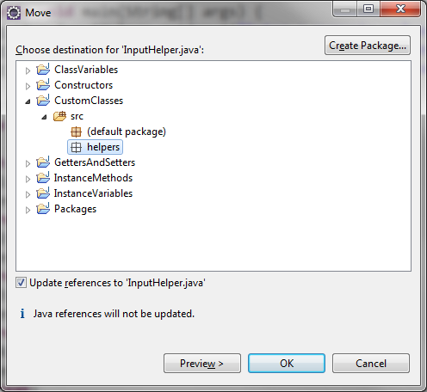

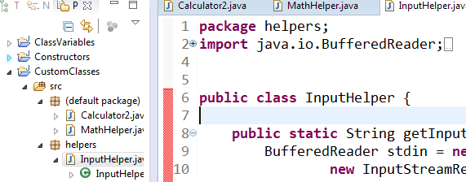



## Instance Methods

* Class method called from definition of the class
  + building up utility functions that pass all data in the call
  + STATIC present
* Instance method call from instance of the class - OBJECT
  + objects stick around and retain their data so its always accessible.
  + STATIC missing
* Method declarations
  + static - class method
  + public - called anywher ein ap
  + private - only within class
  + protected - only within this class or its subclasses
* Object Superclass methods with
* Olive()’s crush() method
* Olive inherits Object() methods/properties

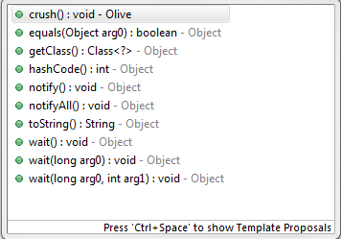

**Code: Main.java**

package com.lynda.olivepress;

import com.lynda.olivepress.olives.Olive;

import com.lynda.olivepress.press.OlivePress;

public class Main {

public static void main(String[] args) {

//creating 3 anonymous Olive objects

Olive[] olives = {new Olive(), new Olive(), new Olive()};

OlivePress press = new OlivePress();

press.getOil(olives);

}

}

**Code: OlivePress.java**

package com.lynda.olivepress.press;

import com.lynda.olivepress.olives.Olive;

public class OlivePress {

public void getOil(Olive[] olives) {

for (Olive olive : olives) {

olive.crush();

}

}

}

**Code: Olive.java**

package com.lynda.olivepress.olives;

public class Olive {

public void crush() {

System.out.println("Ouch!");

}

}



## Constructors

* Constructors have no return value (void, int, etc)
* can create multiple constructors (overloading) with different input specs
* Always create a ‘no argument’ constructor for clarity
  + public OlivePress() { }
* Can Create a new constructor with fields....

**Constructor of the Olive() class**

public Olive() {

System.out.println("Constructor of " + this.name);

}

Creating another constructor to catch argument and populate a field:

public Olive(int oil) {

//this.oil means field(instance variable

//otherwise refers to argument

this.oil = oil;

}

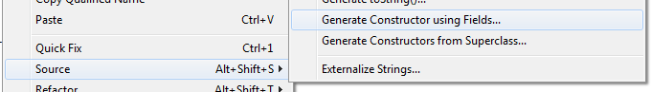

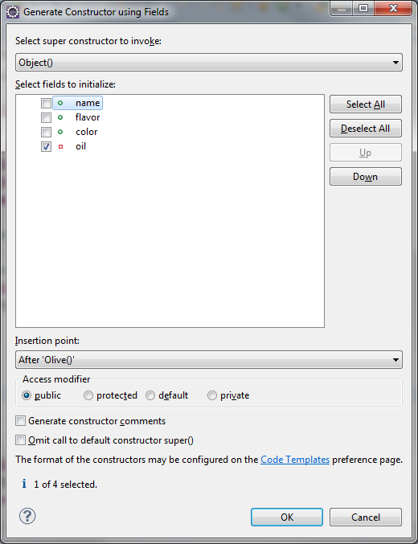

### Code:

package com.lynda.olivepress.olives;

public class Olive {

public String name = "Kalamata";

public String flavor = "Grassy";

public long color = 0x000000;

private int oil = 3;

//constructor, same name as class

//no return on constructors

//can overload the constructor

public Olive() {

System.out.println("Constructor of " + this.name);

}

public Olive(int oil) {

this.oil = oil;

}

public int crush() {

System.out.println("ouch!");

return oil;

}

}



## Getters/Setters

* OO development patters
* Fields should be private
* Get to data with get/set
  + Create private get() and set()

**Eclipse can create get/set code via Source:**

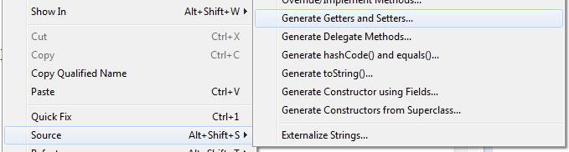

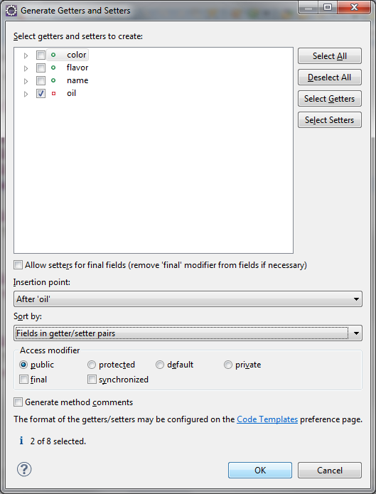

**Creates:**

public int getOil() {

return oil;

}

public void setOil(int oil) {

this.oil = oil;

}

### Code: Main.java

package com.lynda.olivepress;

import java.util.ArrayList;

import com.lynda.olivepress.olives.Olive;

import com.lynda.olivepress.press.OlivePress;

public class Main {

public static void main(String[] args) {

ArrayList<Olive> olives = new ArrayList<Olive>();

Olive olive;

olive = new Olive(2);

System.out.println(olive.name);

olives.add(olive);

olive = new Olive(1);

System.out.println(olive.name);

olives.add(olive);

olive = new Olive(2);

System.out.println(olive.name);

olives.add(olive);

OlivePress press = new OlivePress();

press.getOil(olives);

System.out.println("You got " + press.getTotalOil() + " units of oil");

press.getOil(olives);

System.out.println("You got " + press.getTotalOil() + " units of oil");

}

}

**Code: OlivePress.java**

package com.lynda.olivepress;

import java.util.ArrayList;

import com.lynda.olivepress.olives.Olive;

import com.lynda.olivepress.press.OlivePress;

public class Main {

public static void main(String[] args) {

ArrayList<Olive> olives = new ArrayList<Olive>();

Olive olive;

olive = new Olive(2);

System.out.println(olive.name);

olives.add(olive);

olive = new Olive(1);

System.out.println(olive.name);

olives.add(olive);

olive = new Olive(2);

System.out.println(olive.name);

olives.add(olive);

OlivePress press = new OlivePress();

press.getOil(olives);

System.out.println("You got " + press.getTotalOil() + " units of oil");

press.getOil(olives);

System.out.println("You got " + press.getTotalOil() + " units of oil");

}

}

**Code: Olive.java**

package com.lynda.olivepress;

import java.util.ArrayList;

import com.lynda.olivepress.olives.Olive;

import com.lynda.olivepress.press.OlivePress;

public class Main {

public static void main(String[] args) {

ArrayList<Olive> olives = new ArrayList<Olive>();

Olive olive;

olive = new Olive(2);

System.out.println(olive.name);

olives.add(olive);

olive = new Olive(1);

System.out.println(olive.name);

olives.add(olive);

olive = new Olive(2);

System.out.println(olive.name);

olives.add(olive);

OlivePress press = new OlivePress();

press.getOil(olives);

System.out.println("You got " + press.getTotalOil() + " units of oil");

press.getOil(olives);

System.out.println("You got " + press.getTotalOil() + " units of oil");

}

}



## Class Variables

* Java has no CONSTANT declaration so......

// public - accessible from entire app

// static - class var

// final - value can't be changed

**IN Olive()...**

public static final long BLACK= 0x000000;

**using it**

public long color = Olive.BLACK;



## Inheritance

* Java has only single inheritance - only one inherited parent
* Parent/child
* Base/derived
* Superclass/subclass <- Preferred Java nomenclature
  + By default Object() is the superclass unless directly specified

## Polymorphism

* Can used as Superclass or Subclass
* Declare the object by Superclass

### Superclass can have more than one subclass

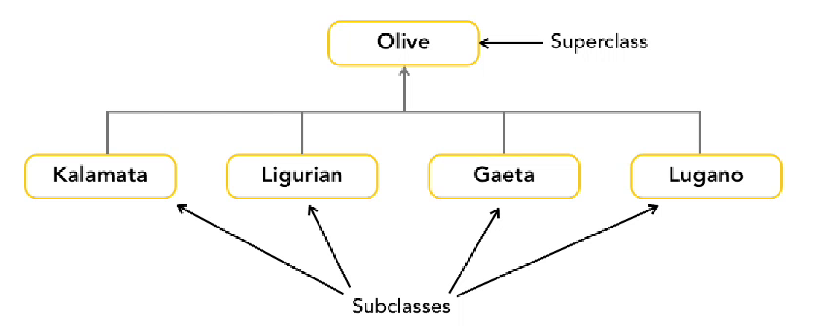

* **Private - only called within own class**
* **Protected - called by own class or subclass**
* **Public - called from anywhere**

### Subclasses extend superclass

**extending Olive by setting inital volume (setVolume)**

public class Kalamata **extends** Olive() {

public Kalamata() {this.setVolume(2);}

}

public class Liguria **extends** Olive() {

public Liguria () {this.setVolume(5);}

}

**…..this creates inheritance**

Olive[] olives = {new Kalamata(), new Liguria(), new Kalamata()};

OlivePress press = new OlivePress(olives);

OliveOil oil - press.getOil;

**Takes Kalamata() class and fits into Superclass Olive()**



## Extending Custom Classes

* Superclass doesnot pass on its constructor so...
* Each subclass needs its own constructor

In subclass... use IDE to copy constructors from the Superclass

Can select all or one...

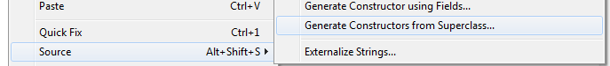

**Superclass Olive() has two constructor methods (its overloaded)**

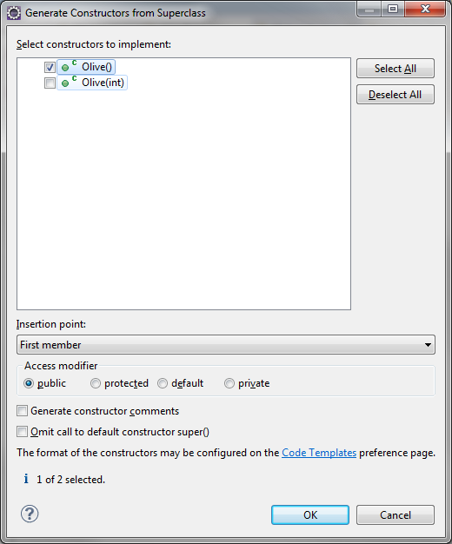

**Creates...**

public Kalamata() {

super();//calling superclass constructor method

// TODO Auto-generated constructor stub

}

### Code: Main

package com.lynda.olivepress;

import java.util.ArrayList;

import com.lynda.olivepress.olives.Kalamata;

import com.lynda.olivepress.olives.Ligurian;

import com.lynda.olivepress.olives.Olive;

import com.lynda.olivepress.press.OlivePress;

public class Main {

public static void main(String[] args) {

ArrayList<Olive> olives = new ArrayList<Olive>();

Olive olive;

//olive = new Olive(2); //Was calling SuperClass

olive = new Kalamata();

System.out.println(olive.name);

olives.add(olive);

olive = new Ligurian();

System.out.println(olive.name);

olives.add(olive);

olive = new Kalamata();

System.out.println(olive.name);

olives.add(olive);

OlivePress press = new OlivePress();

press.getOil(olives);

System.out.println("You got " + press.getTotalOil() +

" units of oil");

press.getOil(olives);

System.out.println("You got " + press.getTotalOil() +

" units of oil");

}

}

**Code:Olive.java**

package com.lynda.olivepress.olives;

public class Olive {

public static final long BLACK = 0x000000;

public static final long GREEN = 0x00ff00;

public String name = "Kalamata";

public String flavor = "Grassy";

public long color = Olive.BLACK;

private int oil = 3;

public int getOil() {

return oil;

}

public void setOil(int oil) {

this.oil = oil;

}

public Olive() {

System.out.println("Constructor of " + this.name);

}

public Olive(int oil) {

setOil(oil);

}

public int crush() {

System.out.println("ouch!");

return oil;

}

}

**Code:Kalamata**

package com.lynda.olivepress.olives;

public class Kalamata extends Olive {

public Kalamata() {

super(2); //calling superclass constructor method and passing '2'

this.name = "Kalamata";

this.flavor = "Grassy";

this.color = Olive.BLACK;

}

}



## Overriding Methods (super.something();)

### Code: Olive.java

package com.lynda.olivepress.olives;

public class Olive {

public static final long BLACK = 0x000000;

public static final long GREEN = 0x00FF00;

public String name = "Kalamata";

public String flavor = "Grassy";

public long color = Olive.BLACK;

private int oil = 3;

public int getOil() {

return oil;

}

public void setOil(int oil) {

this.oil = oil;

}

public Olive() {

System.out.println("Constructor of " + this.name);

}

public Olive(int oil) {

setOil(oil);

}

public int crush() {

System.out.println("crush from superclass");

//System.out.println("ouch!");

return oil;

}

}

**Code: Kalamata.java**

package com.lynda.olivepress.olives;

public class Kalamata extends Olive {

public Kalamata() {

super(2);

this.name = "Kalamata";

this.flavor = "Grassy";

this.color = Olive.BLACK;

}

//Annotation wth @...data type MUST match (super.crush())

@Override

public int crush() {

System.out.println("crush from subclass");

return super.crush();

}

}



## Casting Objects

* As in conversion...upward/downward (int -> long / long -> int)
* casting
  + upcasting - subclass as superclass (SAFE)
  + downcasting - superclass as subclass (RISKY)

//Downcasting - will cause compiler error

Kalamata olive1 =olives.get(0);

//Downcasting Excplicitly

Kalamata olive1 = (Kalamata)olives.get(0);

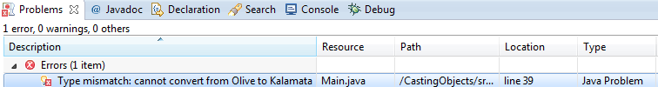

**Create a Kalamata() olive1 from Olive() in ArrayList[0], position 0**

Kalamata olive1 = olives.get(0);

**Create a Kalamata() olive1 from Kalamata() Olive() in ArrayList[0], position 0**

Kalamata olive1 = **(Kalamata)**olives.get(0);

### Code:

**Main.java**

//Downcasting

Kalamata olive1 = **(Kalamata)**olives.get(0);

//**downcast** Olive() to **(Kalamata)**

//(Kalamata)olives.get(0) means USE SUBCLASS

System.out.println("Olive 1 is from " + olive1.getOrigin());

**Kalamata.java (only in the Kalamata subclass, not others..)**

**getOrigin extends Olive()**

public String getOrigin() {

return "Greece";

}



## Interfaces

* Allows definition of classes’ structure
  + final fields
  + method names
  + return data type
* Interfaces provides definition for creating classes
  + Allows for polymorphism due to similarities

### Code:

**This method only accept ArrayLists (part of Collection data type I/F)**

public void getOil(ArrayList<Olive> olives) {}

**This is more flexible and can take any Data Type that implements the Collection I/F**

public void getOil(Collection<Olive> olives) {



## Creating Interfaces

* No constructor methods or other class elements
* Modeling behavior, not dynamic managment of data
* MUST BE PUBLIC

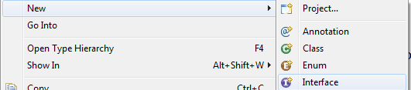

package com.lynda.olivepress.press;

public interface Press {

}

**Creating a class with interface**

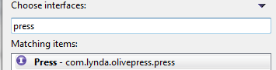

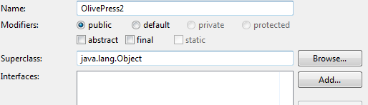

### Code:

package com.lynda.olivepress.press;

import java.util.Collection;

import com.lynda.olivepress.olives.Olive;

public class OlivePress2 implements Press {

@Override

public void getOil(Collection<Olive> olives) {

// TODO Auto-generated method stub

}

@Override

public int getTotalOil() {

// TODO Auto-generated method stub

return 0;

}

@Override

public void setTotalOil(int totalOil) {

// TODO Auto-generated method stub

}

}



## Creating JARs

* Build Project
* File > Export

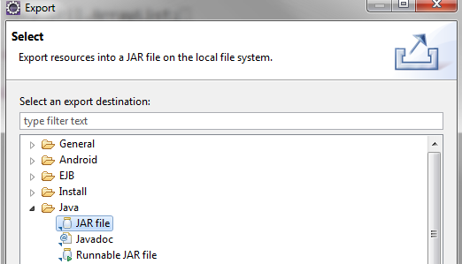

**Don’t select Eclipse .classpath or .project**

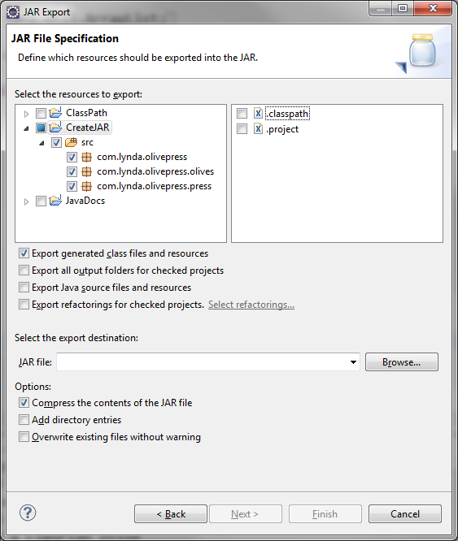

**For Debugging...select these**

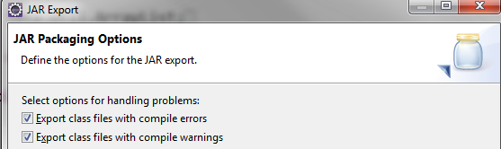

**Manifest file has project metadata**

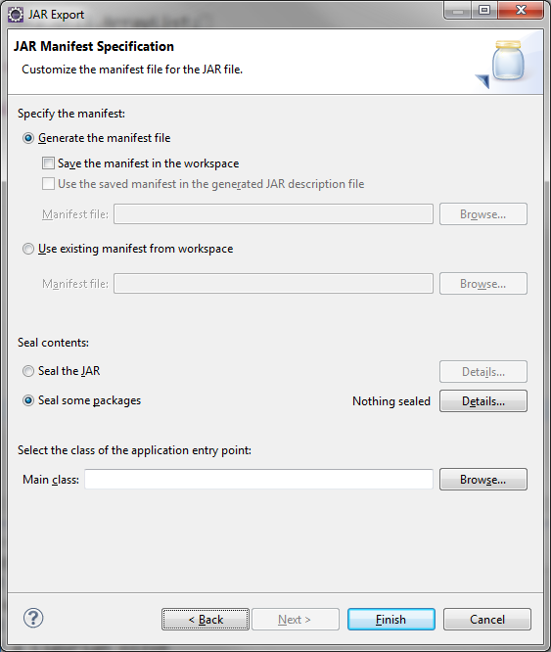



## ClassPath

**Create a batch file and pass %1**

**set CLASSPATH=.**

**OR**

**For Linux**

D:\TEMP\Eclipse>java -classpath .:OlivePressApp.jar com.lynda.olivepress.Main

**For Windows**

D:\TEMP\Eclipse>java -classpath .;OlivePressApp.jar com.lynda.olivepress.Main

You crushed a Kalamata olive

You crushed a Ligurian olive

You crushed a Kalamata olive

You have 5 units of oil

You crushed a Kalamata olive

You crushed a Ligurian olive

You crushed a Kalamata olive

Now you have 10 units of oil

Olive 1 is from Greece



## JavaDocs

**Source > Generate Element Comment**

/\*\*

\* @author SiloSix

\*

\*/

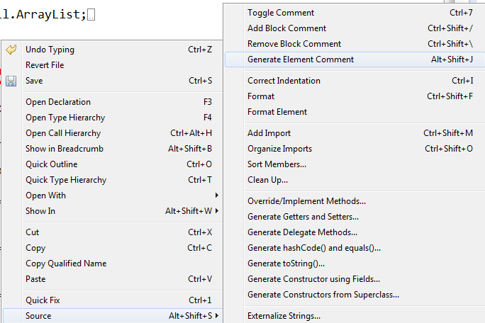

**File > Export > Java > JavaDoc**

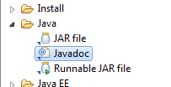

**javadoc.exe: C:\Program Files\Java\jdk1.6.0\_33\bin\javadoc.exe**

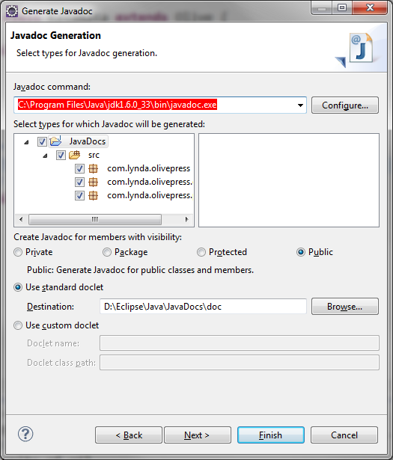

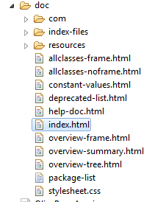



## Resources

* apache commons



## JUnit Class for testing:

* Annotations
  + @Test, @Before, @After, @BeforeClass, @AfterClass, @Ignore

**Code:**

import static org.junit.Assert.\*;

import org.junit.After;

import org.junit.AfterClass;

import org.junit.Before;

import org.junit.BeforeClass;

import org.junit.Ignore;

import org.junit.Test;

public class myJUnit1 {

//No main() method, so JUnit will take over

@BeforeClass

public static void mBeforeTestClass(){

System.out.println("--------ClassBegin------------------");

}

//Annotation: Before EACH @Test

@Before

public void mBeforeTest(){

System.out.println("--------------------------");

}

//Gets executed every time we run the JUnit program

@Test

public void test1(){

if (mMultiply(10,30)==300) {

System.out.println("Multiply Pass");

} else {

System.out.println("Multiply Fail");

fail("Multiply Failed for 10 and 30");

}

}

//Test 2 code

@Test

public void test2(){

if (mAdd(10,30)==300){

System.out.println("Add Pass");

} else {

System.out.println("Add Fail");

fail("Add Failed for 10 and 30");

}

}

//Test 3 code

@Test

public void test3(){

if(mDivide(10,30)==300) {

System.out.println("Divide Pass");

} else {

System.out.println("Divide Fail");

fail("Divide Failed for 10 and 30");

}

}

//Test 4 code won't run due to @Ignore

@Ignore

@Test

public void test4(){

if(mDivide(10,30)==300) {

System.out.println("Divide Pass");

} else {

System.out.println("Divide Fail");

fail("Divide Failed for 10 and 30");

}

}

// Runs after EACH @Test

@After

public void mAfterTest(){

System.out.println("--------------------------");

}

@AfterClass

public static void mAfterTestClass(){

System.out.println("---------Class End-----------------");

}

//Multiply

public int mMultiply(int x, int y){

return x\*y;

}

//Add

public int mAdd(int x, int y){

return x+y;

}

//Divide

public double mDivide(int x, int y){

return x/y;

}

}



# Eclipse Web Services Project

## Get Dependencies:

Axis2 Tools

Eclipse Java Web Developer Tools

Eclipse Web Developer Tools

Eclipse Java EE Developer Tools

JST Server Adapters

JST Server Adapters Extensions



#### Get Axis2 tools

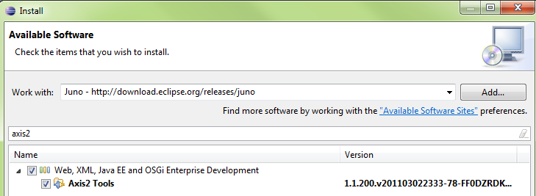

#### Get Eclipse Java Web Developer Tools

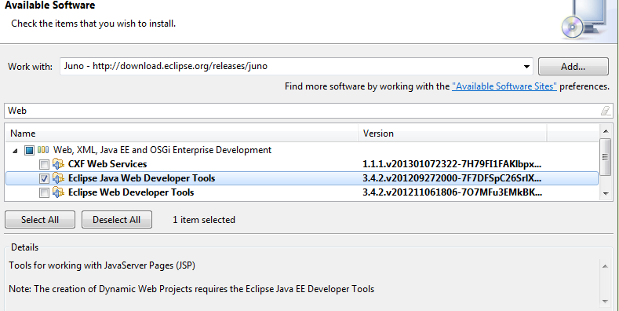

#### Get Eclipse Web Developer Tools

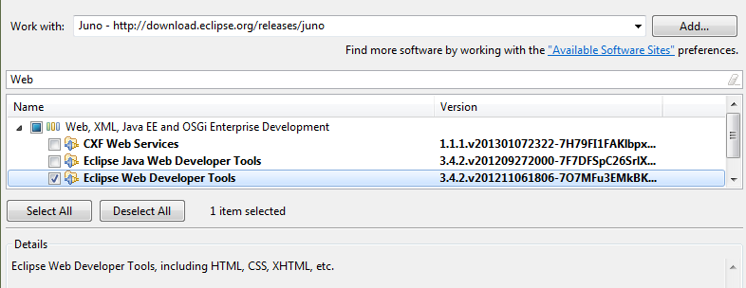

#### Get Eclipse Java EE Developer Tools

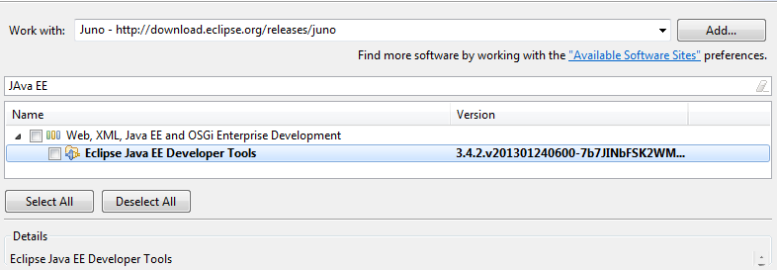

#### Get JST Server Adapters

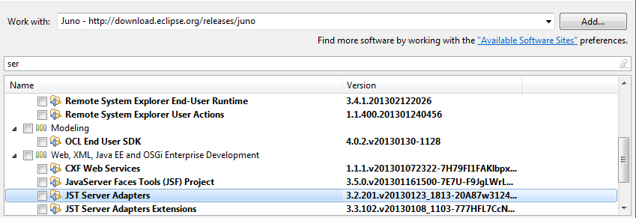

#### Get JST Server Adapters Extensions

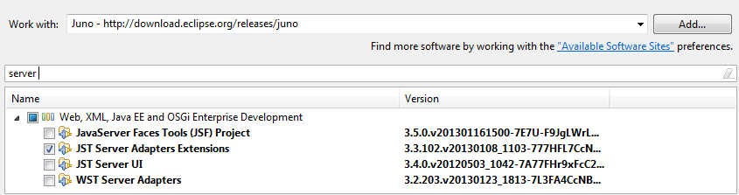

#### Get JAX-WS Tools

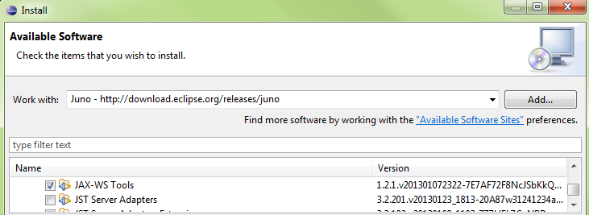



## Create Web Service Server

### Create Project (Server)

#### New\Dynamic Web Project

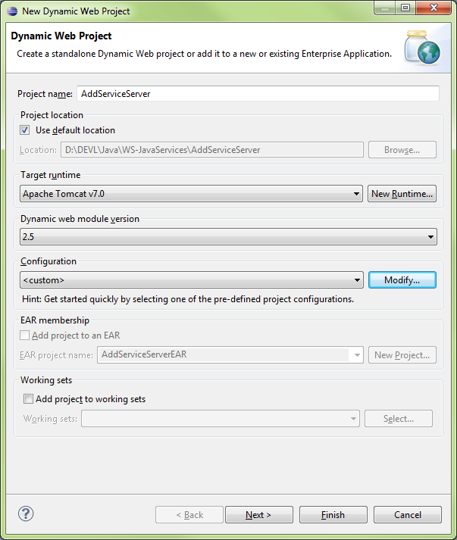

#### New Runtime…

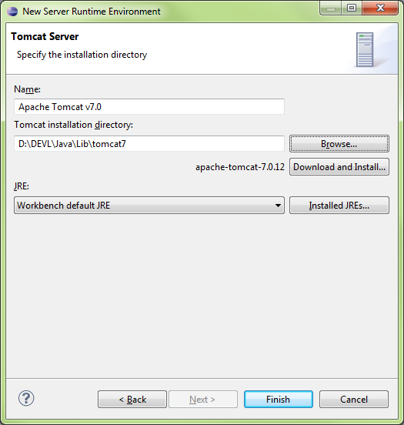

#### Configuration\Modify

Select Axis2 Web Services

Set Dynamic Web Module = 2.5

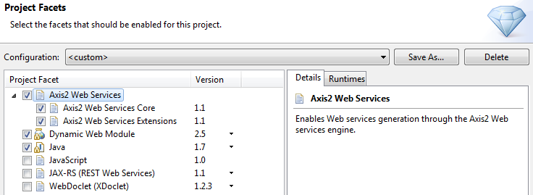

#### Configure Axis2 Web Services Core 1.1

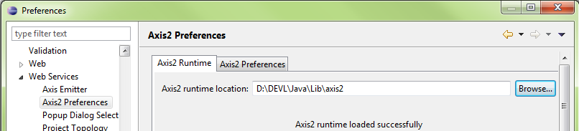

If this step isn’t performed, the following error message will be displayed when attempting to use the Axis2 Project Facet

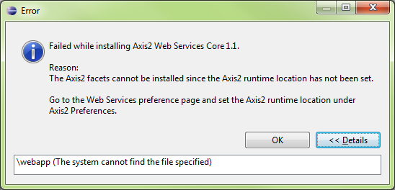



### Create Class (Server)

#### Add Class\OperatorClass

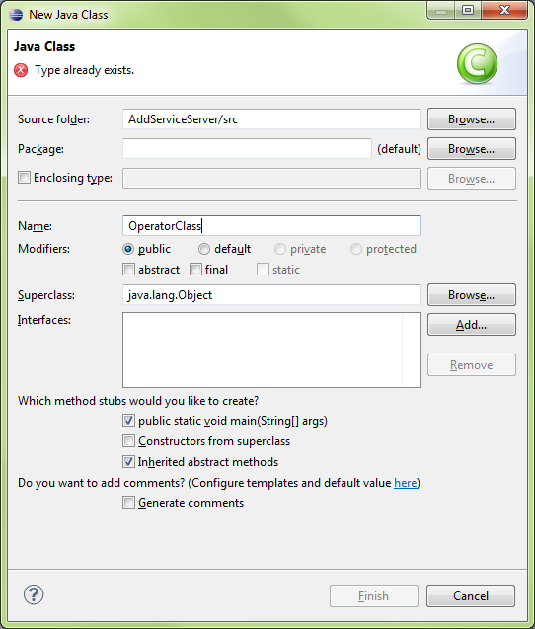

#### OperatorClass Code

|  |
| --- |
| **public** **class** OperatorClass {  **public** **int** Add(**int** a, **int** b){    **return** a+b;    }  } |



### Create Service (Server)

#### New\Web Service

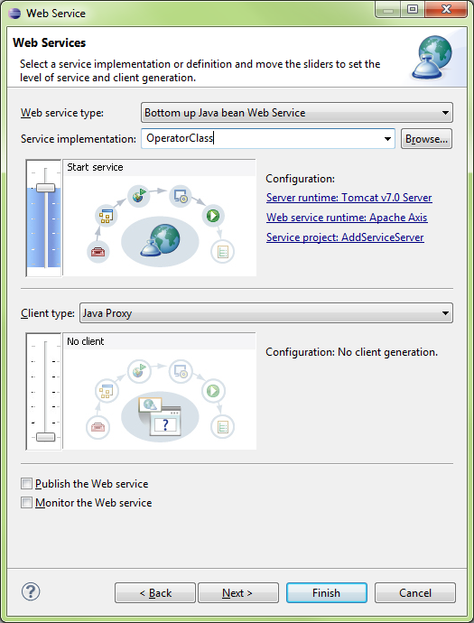

#### Run On Server\AddServiceServer (whole project)

Ensure Tomcat is running, then run

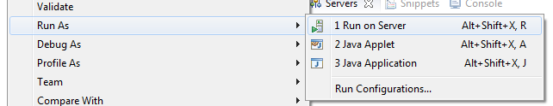

#### AddServiceServer successfully running on the server

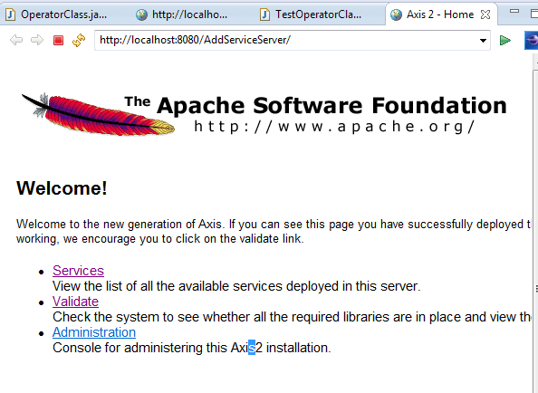

#### Click on Services\OperatorClass

The WSDL will be shown, copy link

<http://localhost:8080/AddServiceServer/services/OperatorClass?wsdl>

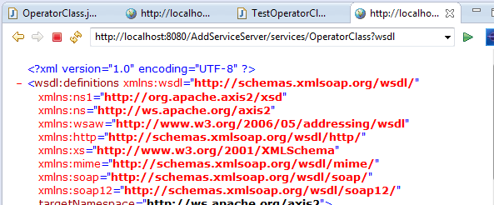

#### WSDL

|  |
| --- |
| <?xml version="1.0" encoding="UTF-8" ?>  [**-**](http://localhost:8080/AddServiceServer/services/OperatorClass?wsdl) <wsdl:definitions xmlns:wsdl="**http://schemas.xmlsoap.org/wsdl/**" xmlns:ns1="**http://org.apache.axis2/xsd**" xmlns:ns="**http://ws.apache.org/axis2**" xmlns:wsaw="**http://www.w3.org/2006/05/addressing/wsdl**" xmlns:http="**http://schemas.xmlsoap.org/wsdl/http/**" xmlns:xs="**http://www.w3.org/2001/XMLSchema**" xmlns:mime="**http://schemas.xmlsoap.org/wsdl/mime/**" xmlns:soap="**http://schemas.xmlsoap.org/wsdl/soap/**" xmlns:soap12="**http://schemas.xmlsoap.org/wsdl/soap12/**" targetNamespace="**http://ws.apache.org/axis2**">    <wsdl:documentation>Please Type your service description here</wsdl:documentation>  [**-**](http://localhost:8080/AddServiceServer/services/OperatorClass?wsdl) <wsdl:types>  [**-**](http://localhost:8080/AddServiceServer/services/OperatorClass?wsdl) <xs:schema attributeFormDefault="**qualified**" elementFormDefault="**qualified**" targetNamespace="**http://ws.apache.org/axis2**">  [**-**](http://localhost:8080/AddServiceServer/services/OperatorClass?wsdl) <xs:element name="**Add**">  [**-**](http://localhost:8080/AddServiceServer/services/OperatorClass?wsdl) <xs:complexType>  [**-**](http://localhost:8080/AddServiceServer/services/OperatorClass?wsdl) <xs:sequence>    <xs:element minOccurs="**0**" name="**a**" type="**xs:int**" />    <xs:element minOccurs="**0**" name="**b**" type="**xs:int**" />    </xs:sequence>    </xs:complexType>    </xs:element>  [**-**](http://localhost:8080/AddServiceServer/services/OperatorClass?wsdl) <xs:element name="**AddResponse**">  [**-**](http://localhost:8080/AddServiceServer/services/OperatorClass?wsdl) <xs:complexType>  [**-**](http://localhost:8080/AddServiceServer/services/OperatorClass?wsdl) <xs:sequence>    <xs:element minOccurs="**0**" name="**return**" type="**xs:int**" />    </xs:sequence>    </xs:complexType>    </xs:element>    </xs:schema>    </wsdl:types>  [**-**](http://localhost:8080/AddServiceServer/services/OperatorClass?wsdl) <wsdl:message name="**AddRequest**">    <wsdl:part name="**parameters**" element="**ns:Add**" />    </wsdl:message>  [**-**](http://localhost:8080/AddServiceServer/services/OperatorClass?wsdl) <wsdl:message name="**AddResponse**">    <wsdl:part name="**parameters**" element="**ns:AddResponse**" />    </wsdl:message>  [**-**](http://localhost:8080/AddServiceServer/services/OperatorClass?wsdl) <wsdl:portType name="**OperatorClassPortType**">  [**-**](http://localhost:8080/AddServiceServer/services/OperatorClass?wsdl) <wsdl:operation name="**Add**">    <wsdl:input message="**ns:AddRequest**" wsaw:Action="**urn:Add**" />    <wsdl:output message="**ns:AddResponse**" wsaw:Action="**urn:AddResponse**" />    </wsdl:operation>    </wsdl:portType>  [**-**](http://localhost:8080/AddServiceServer/services/OperatorClass?wsdl) <wsdl:binding name="**OperatorClassSoap11Binding**" type="**ns:OperatorClassPortType**">    <soap:binding transport="**http://schemas.xmlsoap.org/soap/http**" style="**document**" />  [**-**](http://localhost:8080/AddServiceServer/services/OperatorClass?wsdl) <wsdl:operation name="**Add**">    <soap:operation soapAction="**urn:Add**" style="**document**" />  [**-**](http://localhost:8080/AddServiceServer/services/OperatorClass?wsdl) <wsdl:input>    <soap:body use="**literal**" />    </wsdl:input>  [**-**](http://localhost:8080/AddServiceServer/services/OperatorClass?wsdl) <wsdl:output>    <soap:body use="**literal**" />    </wsdl:output>    </wsdl:operation>    </wsdl:binding>  [**-**](http://localhost:8080/AddServiceServer/services/OperatorClass?wsdl) <wsdl:binding name="**OperatorClassSoap12Binding**" type="**ns:OperatorClassPortType**">    <soap12:binding transport="**http://schemas.xmlsoap.org/soap/http**" style="**document**" />  [**-**](http://localhost:8080/AddServiceServer/services/OperatorClass?wsdl) <wsdl:operation name="**Add**">    <soap12:operation soapAction="**urn:Add**" style="**document**" />  [**-**](http://localhost:8080/AddServiceServer/services/OperatorClass?wsdl) <wsdl:input>    <soap12:body use="**literal**" />    </wsdl:input>  [**-**](http://localhost:8080/AddServiceServer/services/OperatorClass?wsdl) <wsdl:output>    <soap12:body use="**literal**" />    </wsdl:output>    </wsdl:operation>    </wsdl:binding>  [**-**](http://localhost:8080/AddServiceServer/services/OperatorClass?wsdl) <wsdl:binding name="**OperatorClassHttpBinding**" type="**ns:OperatorClassPortType**">    <http:binding verb="**POST**" />  [**-**](http://localhost:8080/AddServiceServer/services/OperatorClass?wsdl) <wsdl:operation name="**Add**">    <http:operation location="**Add**" />  [**-**](http://localhost:8080/AddServiceServer/services/OperatorClass?wsdl) <wsdl:input>    <mime:content type="**application/xml**" part="**parameters**" />    </wsdl:input>  [**-**](http://localhost:8080/AddServiceServer/services/OperatorClass?wsdl) <wsdl:output>    <mime:content type="**application/xml**" part="**parameters**" />    </wsdl:output>    </wsdl:operation>    </wsdl:binding>  [**-**](http://localhost:8080/AddServiceServer/services/OperatorClass?wsdl) <wsdl:service name="**OperatorClass**">  [**-**](http://localhost:8080/AddServiceServer/services/OperatorClass?wsdl) <wsdl:port name="**OperatorClassHttpSoap11Endpoint**" binding="**ns:OperatorClassSoap11Binding**">    <soap:address location="**http://localhost:8080/AddServiceServer/services/OperatorClass.OperatorClassHttpSoap11Endpoint/**" />    </wsdl:port>  [**-**](http://localhost:8080/AddServiceServer/services/OperatorClass?wsdl) <wsdl:port name="**OperatorClassHttpSoap12Endpoint**" binding="**ns:OperatorClassSoap12Binding**">    <soap12:address location="**http://localhost:8080/AddServiceServer/services/OperatorClass.OperatorClassHttpSoap12Endpoint/**" />    </wsdl:port>  [**-**](http://localhost:8080/AddServiceServer/services/OperatorClass?wsdl) <wsdl:port name="**OperatorClassHttpEndpoint**" binding="**ns:OperatorClassHttpBinding**">    <http:address location="**http://localhost:8080/AddServiceServer/services/OperatorClass.OperatorClassHttpEndpoint/**" />    </wsdl:port>    </wsdl:service>    </wsdl:definitions> |



## Create Web Service Client

### Create Project (Client)

#### New\Dynamic Web Project

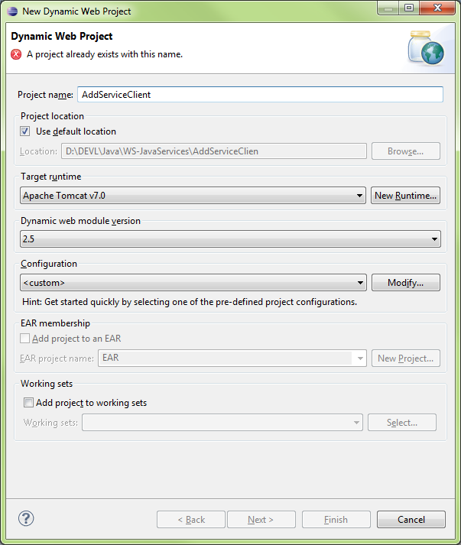

#### Java Settings

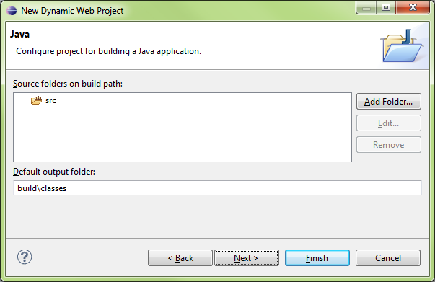

#### Web Module

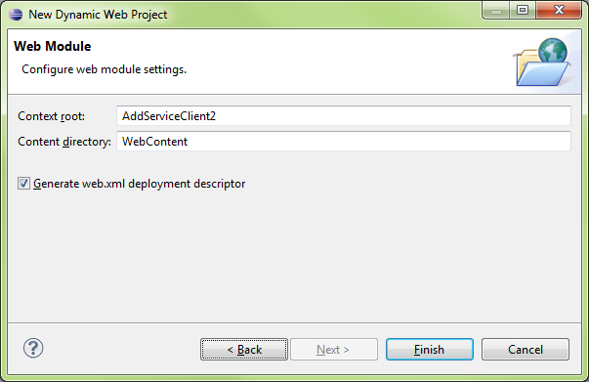



### Create Service (Client)

#### New\Other…\Web Service Client

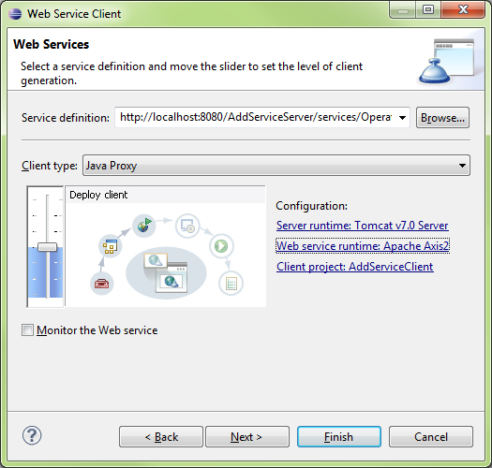

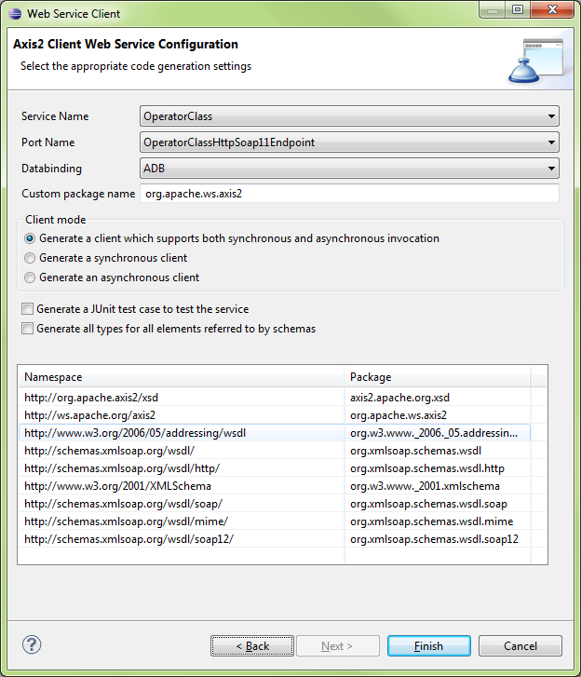



### Create Class (Client)

#### Create New\Class

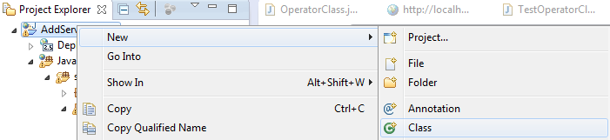

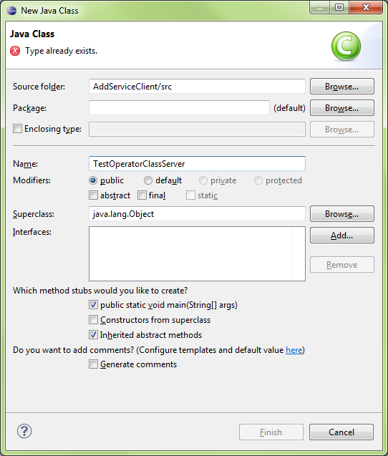

|  |
| --- |
| **import** java.rmi.RemoteException;  **import** org.apache.ws.axis2.OperatorClassStub;  **import** org.apache.ws.axis2.OperatorClassStub.Add;  **public** **class** TestOperatorClassServer {  /\*\*  \* **@param** args  \* **@throws** RemoteException  \*/  **public** **static** **void** main(String[] args) **throws** RemoteException {  // **TODO** Auto-generated method stub  OperatorClassStub classStub = **new** OperatorClassStub();    Add add0 = **new** Add();    add0.setA(8);  add0.setB(9);  **int** finalvalue = classStub.add(add0).get\_return();    System.*out*.println(finalvalue);  }  } |

#### Run the class

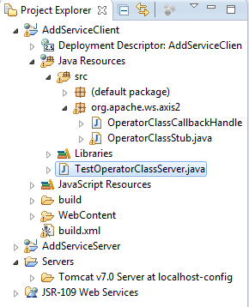

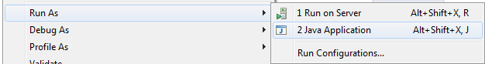



# Installing Java and Eclipse on Ubuntu Linux: 2013 Updates

Do you have a JDK installed? You likely want to put $JDK\_HOME/bin on your PATH, not the /bin of a JRE, as jar comes with JDK, not JRE.

Do this:

1. Delete all installations of Java.
2. Install the [Java SDK](http://www.java.com/en/download/manual.jsp) (self-extracting) into **/opt/jdk1.6.0\_16** (for example)
3. Create a symbolic link: ln -s /opt/jdk1.6.0\_16 /opt/jdk
4. Edit $HOME/.bashrc:

JAVA\_HOME=/opt/jdk  
PATH=$PATH:$HOME/bin:$JAVA\_HOME/bin

1. Logout and log back in.

This offers many advantages:

* You can install multiple versions of the SDK and need only switch a symbolic link.
* You know where all the files are located.
* You know exactly which version of Java is being used.
* No other versions are installed, so there cannot be any conflicts.

I have done this for years and have never had any problems with Java on Linux, except for packages that do not detect that Java is installed and attempt to install the OpenJDK.

Also, stay away from the OpenJDK as its fonts are terrible to behold.



EXTRAS



# EXTRAS

## Tutorial Glassfish Configuration

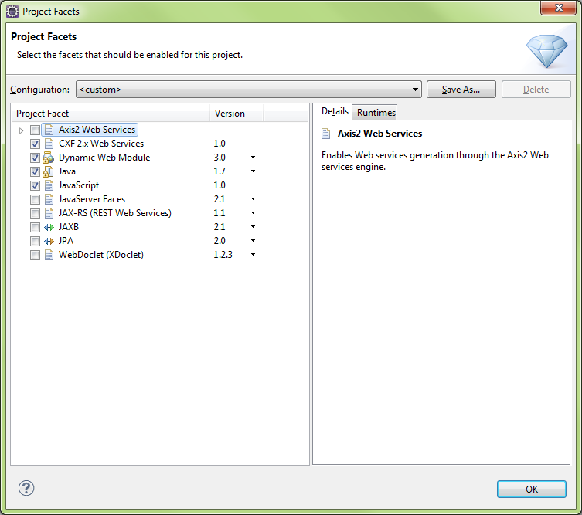

XXX

## Web Services - Attempt1

#### New\Web\Dynamic Web Project

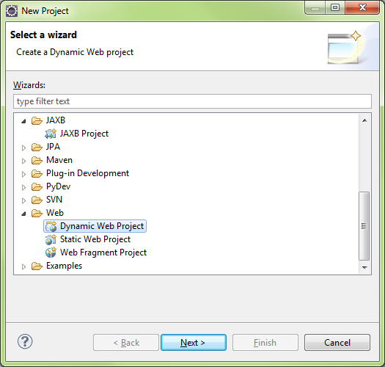

#### Select Tomcat v7

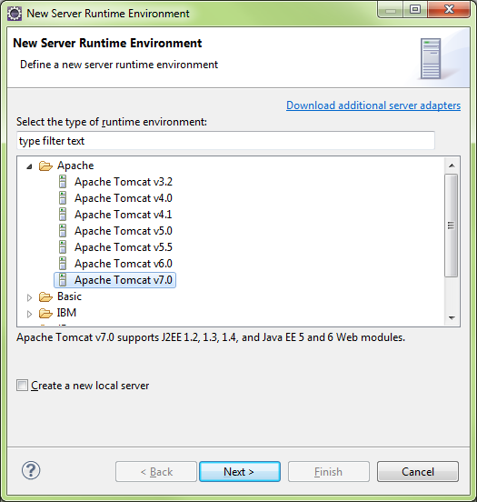

Browse for the Tomcat 7 Runtime on the Tomcat server, it needed Eclipse will download and install the runtime

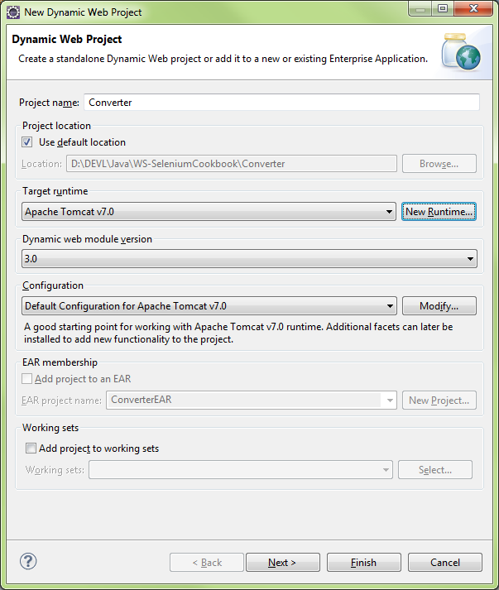

Modify Configuration

#### Tomcat7 default

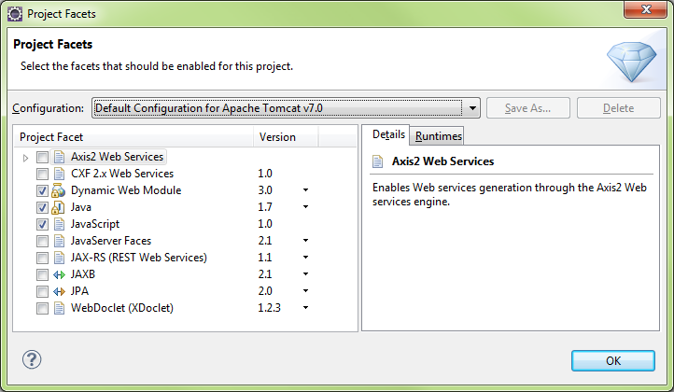

#### Add Axis2 Web Services

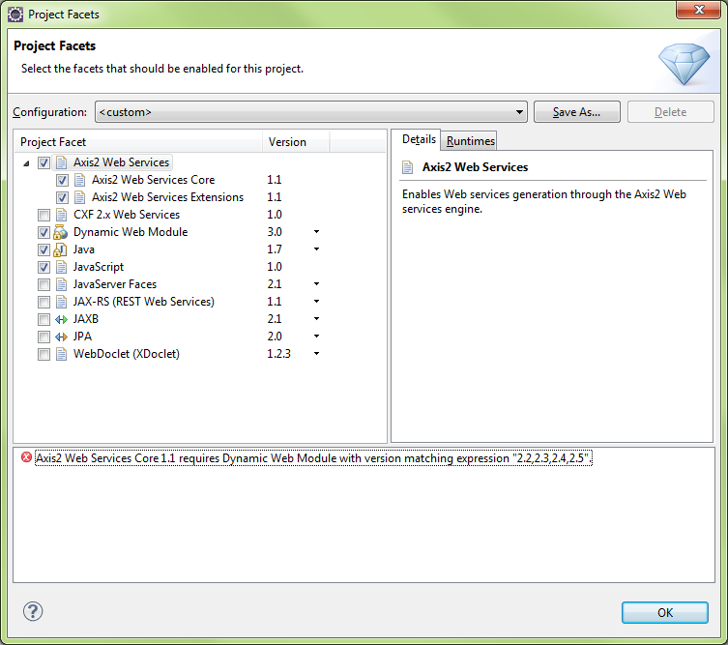

#### Need to select Dynamic Web Module v2.5 to clear above Axis2 error message

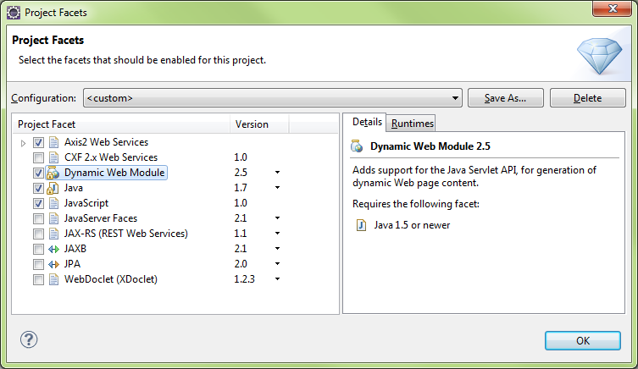

#### Need to add Axis2 Tools (v1.1.200.v201103…

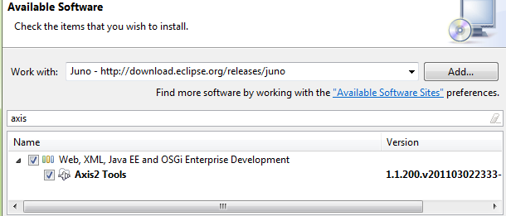

#### 

#### You can set Project facets after the fact via Project\Properties

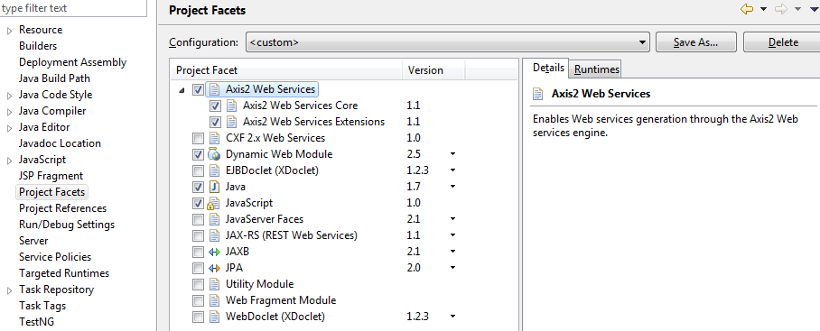

#### Download Apache Axis2 Binaries/Docs/War

<http://axis.apache.org/axis2/java/core/download.cgi>

|  |  |  |  |  |  |  |  |  |  |  |  |  |  |  |  |  |  |  |
| --- | --- | --- | --- | --- | --- | --- | --- | --- | --- | --- | --- | --- | --- | --- | --- | --- | --- | --- |
| Apache Axis2 Releases This page provides links to the release versions of Axis2 Java. For more information, please see [Apache Release FAQ](http://www.apache.org/dev/release.html).  Different types of distributions are available for each released version:   |  |  | | --- | --- | | **Distribution Name** | **Description** | | **Binary Distribution** | This is the complete version of Axis2 and will contain samples as well. Since WS-Addressing implementation and SOAP Monitor utility modules are engaged in to Axis2, by default, this distribution will contain addressing.mar and soapmonitor.mar. But the other modules that are being developed within Axis2 will not be included here, and need to be [downloaded](http://axis.apache.org/axis2/java/core/modules/index.html) separately. | | **Source Distribution** | This will contain the sources of Axis2 standard distribution. One can generate a binary distribution from this by typing $maven dist-bin ([Set up Axis2 environment](http://axis.apache.org/axis2/java/core/docs/installationguide.html" \l "env-src) before running this command). Useful for advanced users. | | **WAR (Web Archive) Distribution** | This will be the web application of Axis2 which can be deployed in most of the servlet containers. | | **Documents Distribution** | This will contain all the documentation in one package. |  1.6.x releases The following versions are available:   |  |  |  |  | | --- | --- | --- | --- | | **Version** | **Date** | **Description** | **Distribution** | | **1.6.2** | 17 - Apr - 2012 | 1.6.2 Release (Mirrored) | Binary Distribution [zip](http://www.poolsaboveground.com/apache/axis/axis2/java/core/1.6.2/axis2-1.6.2-bin.zip) | [MD5](http://www.apache.org/dist/axis/axis2/java/core/1.6.2/axis2-1.6.2-bin.zip.md5) | [PGP](http://www.apache.org/dist/axis/axis2/java/core/1.6.2/axis2-1.6.2-bin.zip.asc)  Source Distribution [zip](http://www.poolsaboveground.com/apache/axis/axis2/java/core/1.6.2/axis2-1.6.2-src.zip) | [MD5](http://www.apache.org/dist/axis/axis2/java/core/1.6.2/axis2-1.6.2-src.zip.md5) | [PGP](http://www.apache.org/dist/axis/axis2/java/core/1.6.2/axis2-1.6.2-src.zip.asc)  WAR Distribution [zip](http://www.poolsaboveground.com/apache/axis/axis2/java/core/1.6.2/axis2-1.6.2-war.zip) | [MD5](http://www.apache.org/dist/axis/axis2/java/core/1.6.2/axis2-1.6.2-war.zip.md5) | [PGP](http://www.apache.org/dist/axis/axis2/java/core/1.6.2/axis2-1.6.2-war.zip.asc)  Documents Distribution [zip](http://www.poolsaboveground.com/apache/axis/axis2/java/core/1.6.2/axis2-1.6.2-docs.zip) | [MD5](http://www.apache.org/dist/axis/axis2/java/core/1.6.2/axis2-1.6.2-docs.zip.md5) | [PGP](http://www.apache.org/dist/axis/axis2/java/core/1.6.2/axis2-1.6.2-docs.zip.asc) | |

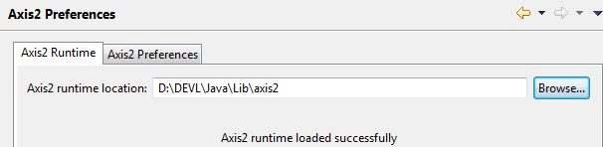

#### Create a Class

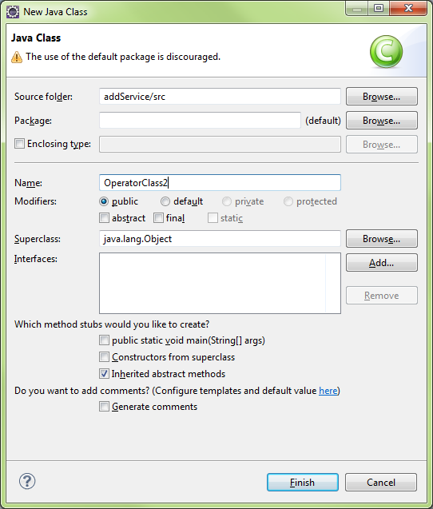

#### Run the Wizard for new WebService

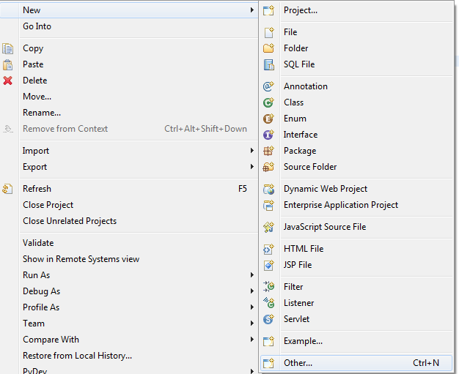

#### Select Web Service Wizard

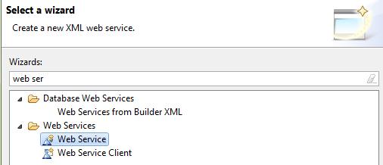

#### Click Browse and enter the class name to use for WebService

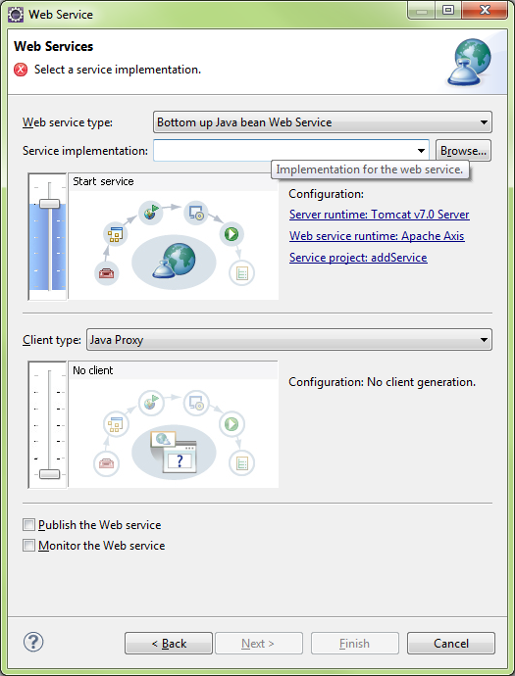

#### OperatorClass

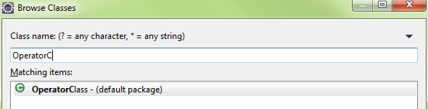

Server Selection

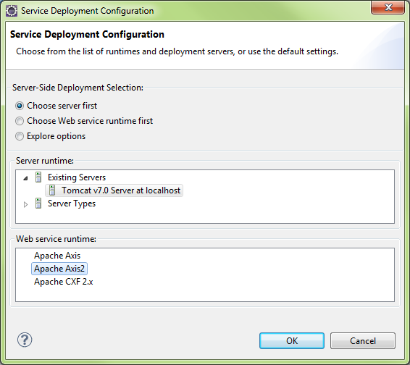

#### Generate a default services.xml file

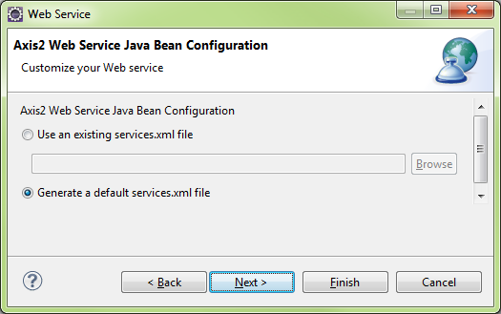



#### Tomcat will start..

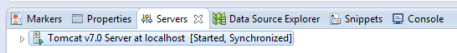

Run OperatorClass.java on the Tomcat Server..

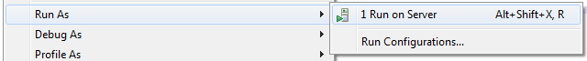

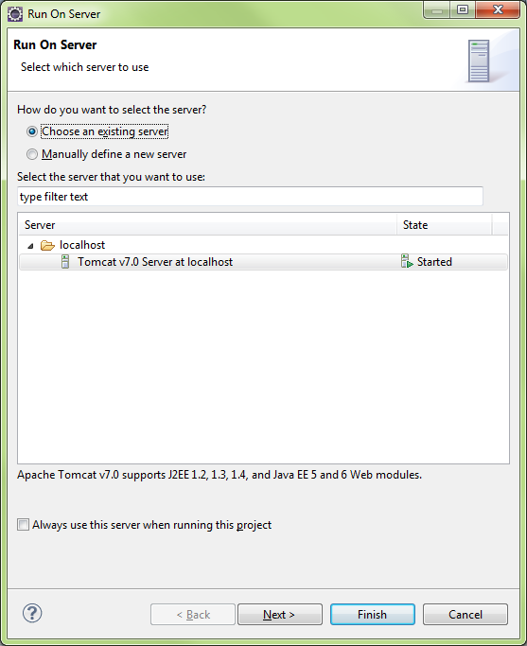

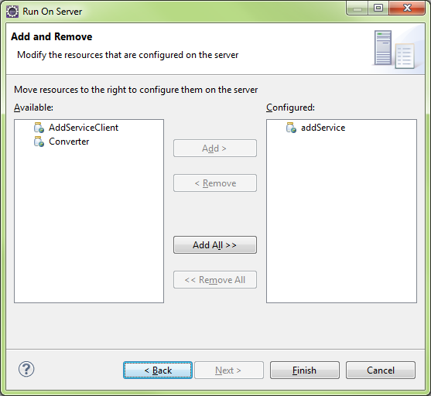

#### Create Web Service Client

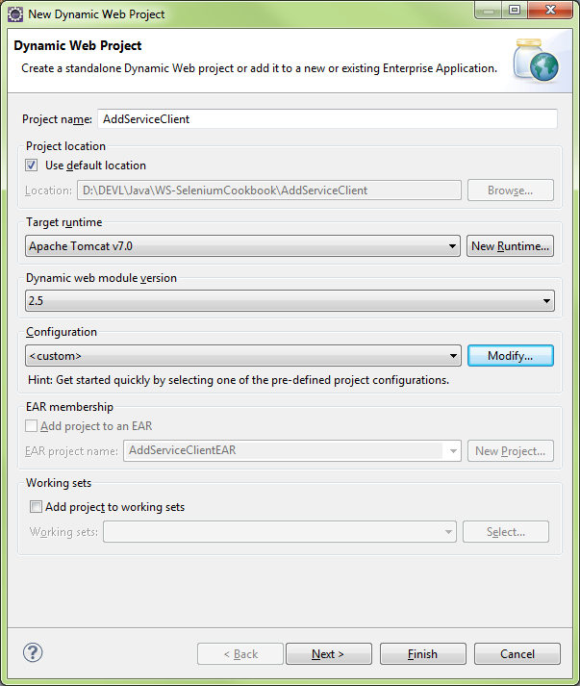

Create Web Services Client

